CRISPY SKIN WHITE FISH WITH CHIVE DRESSING  COOK TIME: 6 mins  SOURCE: Unknown  #fish #Mediterranean #pan-fry | 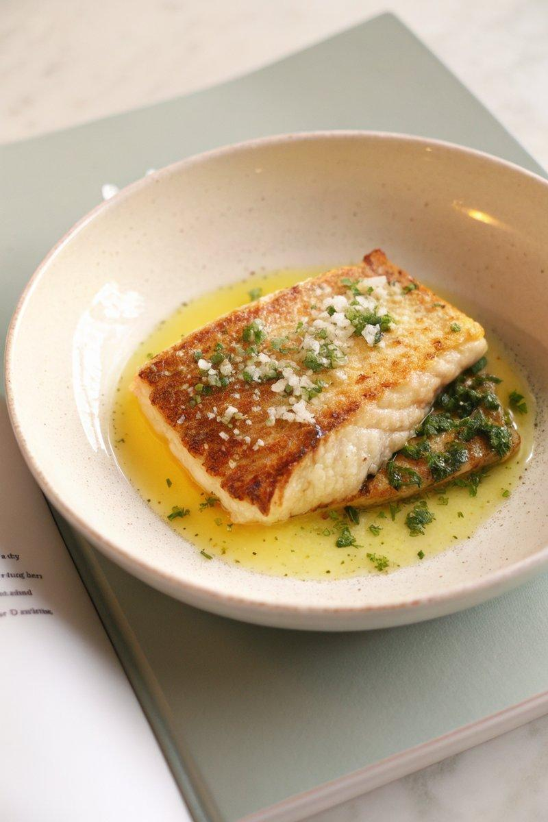

INGREDIENTS  - {'group': 'Main', 'item': '4 skin-on white fish fillets (e.g., red snapper or grouper)'}  - {'group': 'Seasoning', 'item': 'Kosher salt, to taste'}  - {'group': 'Cooking', 'item': '2 tbsp neutral-tasting oil'}  - {'group': 'Dressing', 'item': '3 tbsp extra virgin olive oil'}  - {'group': 'Dressing', 'item': '2 tbsp thinly sliced chives'}  - {'group': 'Garnish', 'item': 'Flaky sea salt'} | PREP  Season the fish fillets generously with kosher salt and let them rest at room temperature for 20 minutes to allow the salt to penetrate and firm up the flesh.  COOK  Heat a skillet over medium-high heat and add the neutral oil. Once hot, pat the fish fillets dry and place them skin-side down in the skillet. Hold the fish down with a spatula to prevent curling. Sear for 2-3 minutes until the skin is crispy and the flesh is cooked halfway. Carefully flip the fillets and cook for another 2-3 minutes until the flesh is just cooked through.  PLATING  Mix the olive oil and chives in a small bowl. Serve the fish fillets with a generous drizzle of the chive dressing and a sprinkle of flaky sea salt.

NOTES:
For best results, ensure the skillet is very hot before adding the fish to achieve a crispy skin. Adjust seasoning with flaky sea salt just before serving.

