SPICY PERI-PERI ROASTED CHICKEN  COOK TIME: 1 hr 30 mins  SOURCE: Unknown  #chicken #African #roast | 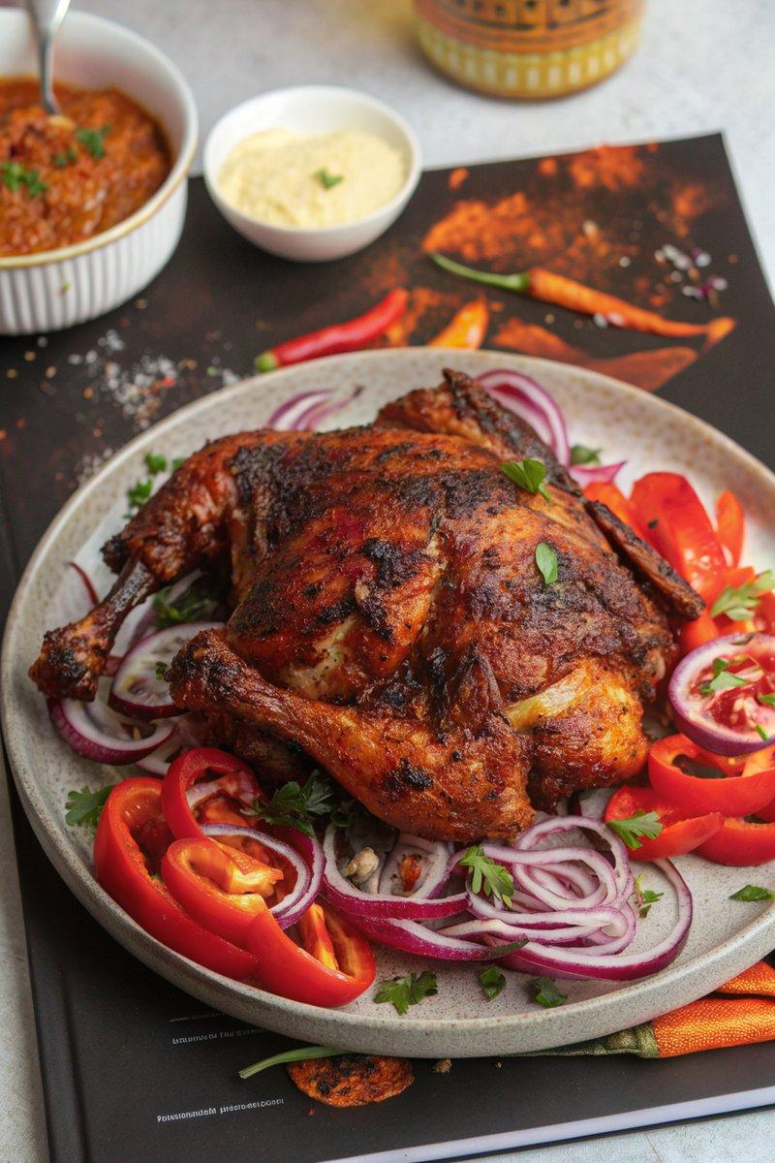

INGREDIENTS  - {'group': 'Peri-Peri Sauce', 'item': '2 red bell peppers, sliced'}  - {'group': 'Peri-Peri Sauce', 'item': '2 red onions, chopped'}  - {'group': 'Peri-Peri Sauce', 'item': '120ml sunflower oil'}  - {'group': 'Peri-Peri Sauce', 'item': '1 tsp paprika'}  - {'group': 'Peri-Peri Sauce', 'item': '1 tsp smoked paprika'}  - {'group': 'Peri-Peri Sauce', 'item': '2 tsp cayenne pepper'}  - {'group': 'Peri-Peri Sauce', 'item': '1 tsp salt'}  - {'group': 'Peri-Peri Sauce', 'item': '4 garlic cloves, peeled'}  - {'group': 'Peri-Peri Sauce', 'item': '2 red serrano chillies, deseeded'}  - {'group': 'Peri-Peri Sauce', 'item': "10 dried African bird's eye chillies"}  - {'group': 'Peri-Peri Sauce', 'item': '1/4 tsp white pepper'}  - {'group': 'Peri-Peri Sauce', 'item': 'Zest and juice of 1 lemon'}  - {'group': 'Peri-Peri Sauce', 'item': '1/4 tsp dried rosemary'}  - {'group': 'Peri-Peri Sauce', 'item': '4 tbsp red wine vinegar'}  - {'group': 'Main', 'item': '1 medium chicken (1.4-1.6kg)'}  - {'group': 'Main', 'item': '1/2 tsp salt'}  - {'group': 'Main', 'item': '1/2 tsp ground black pepper'} | PREP  Preheat the oven to 180°C (350°F (175°C)). Slice the red peppers and chop the red onions into large chunks. Deseed and slice the serrano chillies. Zest and juice the lemon.  COOK  Place the peppers and onions on a baking tray, drizzle with 2 tbsp of sunflower oil, and sprinkle with paprika, smoked paprika, cayenne pepper, and salt. Roast for 20 mins. Add garlic and serrano chillies, roast for another 10 mins. Blend roasted vegetables with dried chillies, white pepper, lemon zest and juice, dried rosemary, remaining sunflower oil, and red wine vinegar until smooth. Spatchcock the chicken by removing the backbone and flattening it. Place the chicken on a baking tray, coat with one-third of the sauce, and season with salt and black pepper. Roast for 45 mins, baste with more sauce, and roast for an additional 10-15 mins until cooked through.  PLATING  Let the chicken rest for 10 mins before serving. Serve with the remaining peri-peri sauce on the side.

NOTES:
The peri-peri sauce can be stored in the refrigerator for up to 2 weeks.

