THAI GREEN CHICKEN CURRY  COOK TIME: 25 mins  SOURCE: Unknown  #chicken #asian #stir-fry | 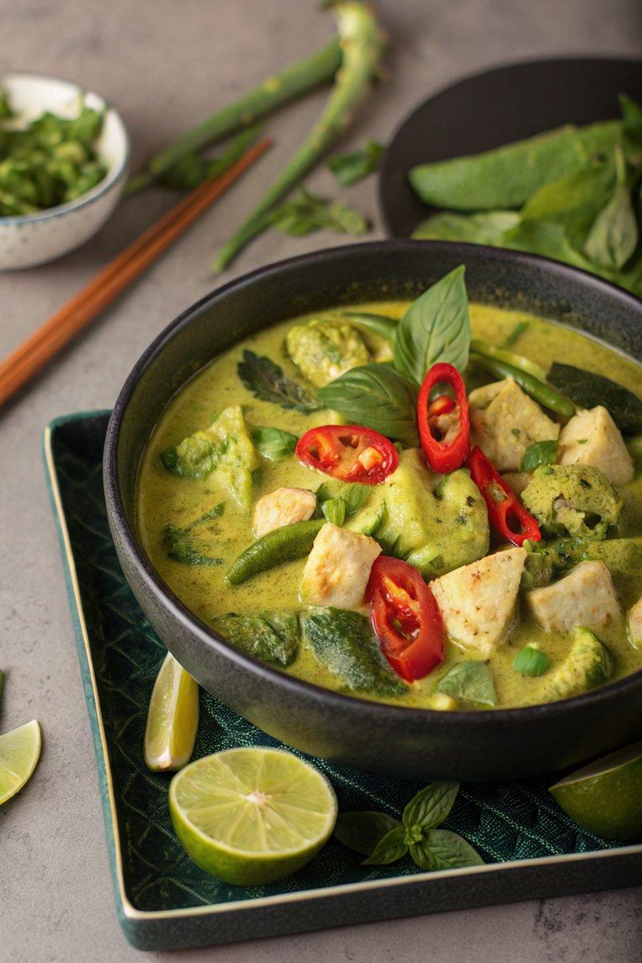

INGREDIENTS  - {'group': 'Curry Paste', 'item': '3-6 green chillies, 6 spring onions, 2 tsp lemongrass paste, 1 thumb-size piece of ginger, 4 garlic cloves, 6 kaffir lime leaves, zest and juice of 1 lime, 1/2 tsp salt, 1/4 tsp white pepper, 1/2 tbsp ground cumin, 1 tbsp ground coriander, 1 tsp shrimp paste, 2 tsp fish sauce, a large bunch of coriander'}  - {'group': 'Main', 'item': '2 tbsp sunflower oil, 800g chicken breasts, 1 chicken stock cube, 400ml coconut milk, 1 head of broccoli, 150g sugar snap peas, 255g can bamboo shoots, 1 tsp light brown sugar'}  - {'group': 'To Serve', 'item': 'cooked rice, Thai basil leaves, freshly chopped red chillies'} | PREP  In a blender, combine green chillies, spring onions, lemongrass paste, ginger, garlic, kaffir lime leaves, lime zest and juice, salt, white pepper, cumin, ground coriander, shrimp paste, and fish sauce. Blend until smooth, adding coriander and blending again until fully combined.  COOK  Heat sunflower oil in a large frying pan over medium-high heat. Add chicken pieces and sauté for 5-6 mins until cooked through. Stir in 4 heaped tbsp of the prepared curry paste and cook for 2-3 mins. Crumble in the chicken stock cube, pour in coconut milk, and heat until hot but not boiling. Add broccoli, sugar snap peas, and bamboo shoots, cooking for a few more mins until vegetables are tender-crisp. Stir in light brown sugar.  PLATING  Serve the curry over cooked rice, garnished with Thai basil leaves and freshly chopped red chillies.

NOTES:
This curry can be made ahead and stored in the refrigerator for up to a day. Reheat gently to avoid splitting the coconut milk.

