THAI RED CHICKEN CURRY  COOK TIME: 25 mins  SOURCE: Unknown  #chicken #asian #sauté | 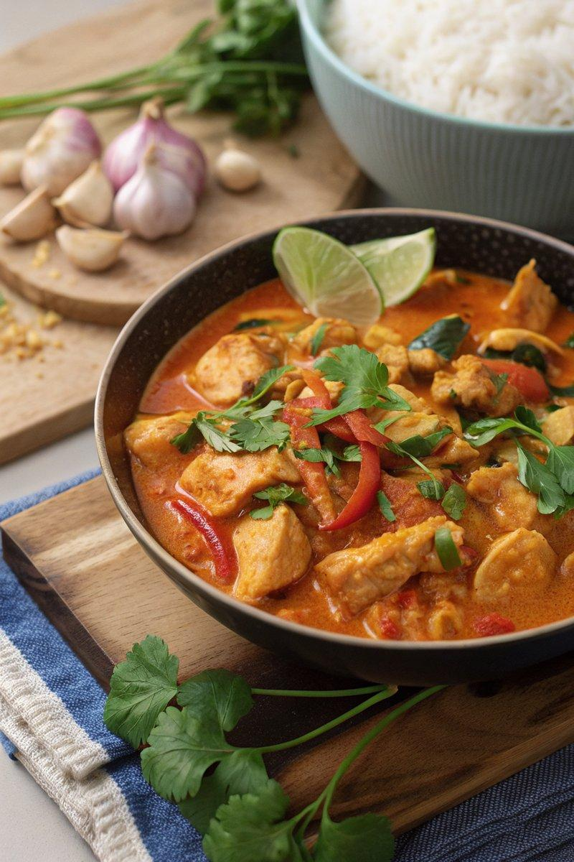

INGREDIENTS  - {'group': 'Main', 'item': '1 tbsp sunflower oil'}  - {'group': 'Main', 'item': '1 onion, peeled and chopped'}  - {'group': 'Main', 'item': '600g chicken breasts, chopped into bite-size pieces'}  - {'group': 'Main', 'item': '2 garlic cloves, peeled and minced'}  - {'group': 'Main', 'item': '1 tsp minced ginger'}  - {'group': 'Main', 'item': '1 tsp lemongrass paste'}  - {'group': 'Main', 'item': '1 chicken stock cube, crumbled'}  - {'group': 'Sauce', 'item': '4 tbsp red Thai curry paste'}  - {'group': 'Main', 'item': '1 red bell pepper, sliced'}  - {'group': 'Sauce', 'item': '400ml coconut milk'}  - {'group': 'Sauce', 'item': '2 tsp fish sauce'}  - {'group': 'Sauce', 'item': '1 tbsp palm sugar or light brown muscovado sugar'}  - {'group': 'Main', 'item': '255g can bamboo shoots, drained'}  - {'group': 'Garnish', 'item': '10 Thai basil leaves'}  - {'group': 'Garnish', 'item': '1 tbsp lime juice (about ½ lime)'}  - {'group': 'For Serving', 'item': 'cooked rice'}  - {'group': 'Garnish', 'item': 'fresh coriander (cilantro)'}  - {'group': 'Garnish', 'item': 'Thai chillies, thinly sliced'}  - {'group': 'Garnish', 'item': '1 lime, sliced into wedges'} | PREP  Chop the onion and chicken into bite-size pieces. Mince the garlic and ginger. Slice the red bell pepper and prepare the lime juice.  COOK  Heat the sunflower oil in a large frying pan over medium-high heat. Sauté the onion for 3-4 mins until softened. Add the chicken pieces and cook for 2-3 mins until sealed. Stir in the garlic, ginger, lemongrass paste, and crumbled stock cube, coating the chicken well. Add the red curry paste and cook for another 3 mins. Mix in the sliced bell pepper and cook for 1 min. Pour in the coconut milk, fish sauce, palm sugar, bamboo shoots, and Thai basil leaves. Bring to a boil, then reduce to a simmer for 10 mins until the sauce thickens.  PLATING  Stir in the lime juice before serving. Serve the curry over cooked rice, garnished with fresh Thai basil leaves, coriander, sliced chillies, and lime wedges.

NOTES:
For a richer flavour, use full-fat coconut milk. The curry can be made ahead and stored in the refrigerator for up to 2 days. Reheat thoroughly before serving.

