CREAMY PANEER CURRY  COOK TIME: 25 mins  SOURCE: Unknown  #vegetarian #Indian #sauté | 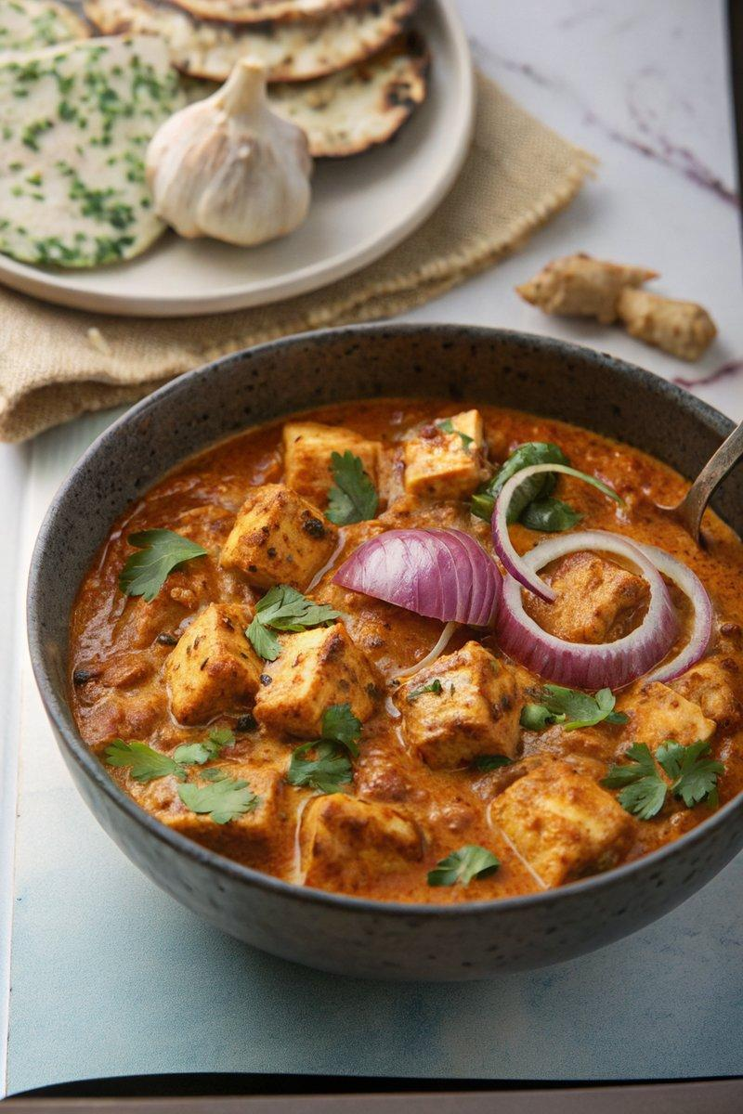

INGREDIENTS  - {'group': 'Main', 'item': '450g paneer cheese, chopped into bite-size chunks'}  - {'group': 'Sauce', 'item': '1 large onion, peeled and roughly chopped'}  - {'group': 'Sauce', 'item': '4 garlic cloves, peeled'}  - {'group': 'Sauce', 'item': '1 thumb-sized piece of ginger, peeled and roughly chopped'}  - {'group': 'Sauce', 'item': '3 tbsp unsalted butter'}  - {'group': 'Sauce', 'item': '1 tbsp sunflower oil'}  - {'group': 'Sauce', 'item': '1/4 tsp salt'}  - {'group': 'Sauce', 'item': '1 1/2 tbsp garam masala'}  - {'group': 'Sauce', 'item': '1 tbsp medium-heat curry powder'}  - {'group': 'Sauce', 'item': '1 tsp paprika'}  - {'group': 'Sauce', 'item': '1/2 tsp cinnamon'}  - {'group': 'Sauce', 'item': '180 ml chicken stock'}  - {'group': 'Sauce', 'item': '400g passata'}  - {'group': 'Sauce', 'item': '2 tbsp tomato purée'}  - {'group': 'Sauce', 'item': '2 tsp sugar'}  - {'group': 'Sauce', 'item': '6 cardamom pods'}  - {'group': 'Sauce', 'item': '175 ml double cream'}  - {'group': 'Garnish', 'item': 'fresh coriander, roughly chopped'}  - {'group': 'Garnish', 'item': 'thinly sliced red onion'}  - {'group': 'Garnish', 'item': 'nigella seeds'} | PREP  Blend the onion, garlic, and ginger in a food processor until smooth.  COOK  In a large frying pan, heat the butter and oil over medium-high heat. Add the blended onion mixture and sauté for 5-6 mins until the onion browns at the edges. Stir in salt, garam masala, curry powder, paprika, and cinnamon, cooking for 1-2 mins until fragrant. Pour in the chicken stock, passata, tomato purée, sugar, and cardamom pods. Bring to a boil, then simmer for 10 mins until thickened. Remove the cardamom pods, stir in the cream, and heat through. Add the paneer and cook for 3 mins until heated through.  PLATING  Serve the curry topped with fresh coriander, red onion slices, and a sprinkle of nigella seeds. Accompany with naan for dipping.

NOTES:
For a spicier version, add fresh chillies to the sauce. Sew cardamom pods together with cotton for easy removal.

