STICKY CHINESE-STYLE PORK BELLY  COOK TIME: 2 hrs 15 mins  SOURCE: Unknown  #pork #asian #pan-fry | 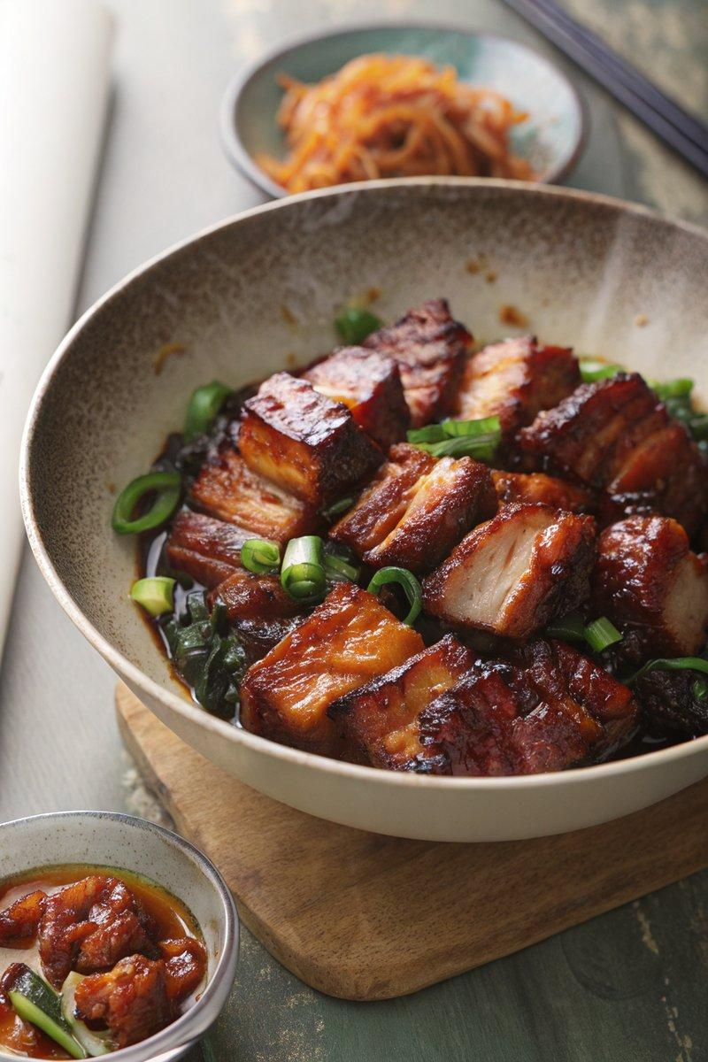

INGREDIENTS  - {'group': 'Main', 'item': '1kg pork belly, rindless, sliced'}  - {'group': 'Main', 'item': '1L hot chicken or vegetable stock'}  - {'group': 'Main', 'item': '1 tsp minced ginger'}  - {'group': 'Main', 'item': '3 garlic cloves, halved'}  - {'group': 'Main', 'item': '1 tbsp rice wine'}  - {'group': 'Main', 'item': '1 tbsp caster sugar'}  - {'group': 'Glaze', 'item': '2 tbsp sunflower oil'}  - {'group': 'Glaze', 'item': '1 tsp minced ginger'}  - {'group': 'Glaze', 'item': '1 red chilli, finely chopped'}  - {'group': 'Glaze', 'item': '2 tbsp honey'}  - {'group': 'Glaze', 'item': '2 tbsp brown sugar'}  - {'group': 'Glaze', 'item': '3 tbsp dark soy sauce'}  - {'group': 'Glaze', 'item': '1 tsp lemongrass paste'}  - {'group': 'Seasoning', 'item': 'Salt and pepper, to taste'} | PREP  Slice the pork belly into even slices. Mince the ginger and halve the garlic cloves. Finely chop the red chilli.  COOK  In a large casserole pan, combine the pork belly slices, stock, minced ginger, garlic, rice wine, and caster sugar. Bring to a boil, then cover and simmer gently for 2 hours. Drain the pork, reserving the liquid if desired. Slice the pork into bite-sized chunks. In a small bowl, mix the glaze ingredients except for 1 tbsp of oil. Heat the remaining oil in a frying pan over medium-high heat. Season the pork chunks with salt and pepper, then fry until golden, about 5 mins. Pour the glaze over the pork and cook for another 2-3 mins until sticky.  PLATING  Serve the sticky pork belly hot, garnished with additional chopped chilli if desired, alongside steamed rice and stir-fried vegetables.

NOTES:
The initial cooking of the pork can be done in a slow cooker on high for 4-5 hours or low for 6-7 hours. The pork and glaze can be prepared ahead and refrigerated separately.

