CRISPY CHILLI BEEF STIR-FRY  COOK TIME: 20 mins  SOURCE: Unknown  #beef #asian #stir-fry | 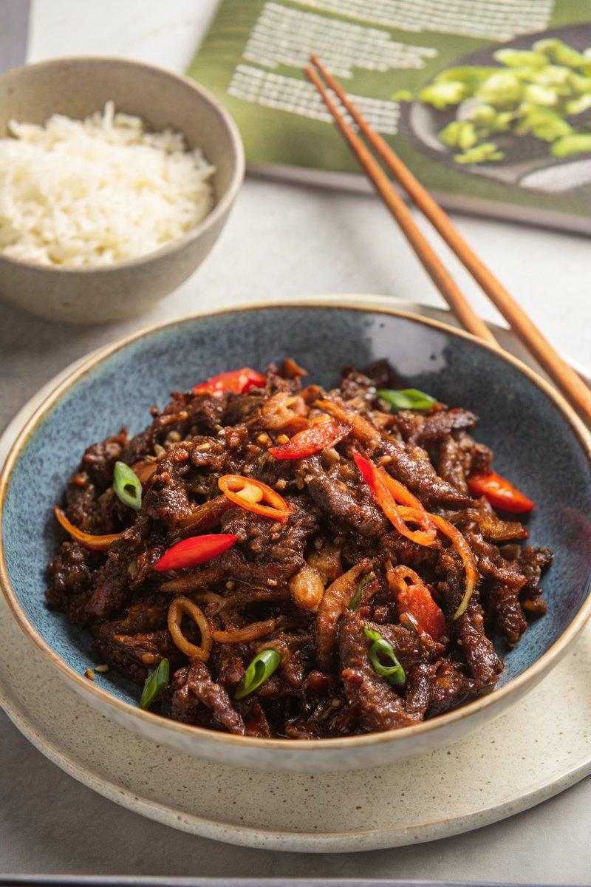

INGREDIENTS  - {'group': 'Main', 'item': '360g thin-cut sirloin steaks, cut into thin strips'}  - {'group': 'Main', 'item': '1 small egg'}  - {'group': 'Main', 'item': '4 tbsp cornflour'}  - {'group': 'Main', 'item': '1/4 tsp salt'}  - {'group': 'Main', 'item': '1/4 tsp ground black pepper'}  - {'group': 'Main', 'item': '1/2 tsp white pepper'}  - {'group': 'Main', 'item': '4 1/2 tbsp sunflower oil'}  - {'group': 'Sauce', 'item': '1 onion, peeled and sliced into thin strips'}  - {'group': 'Sauce', 'item': '1 red chilli, finely sliced'}  - {'group': 'Sauce', 'item': '1 tsp minced ginger'}  - {'group': 'Sauce', 'item': '3 garlic cloves, minced'}  - {'group': 'Sauce', 'item': '2 tbsp rice vinegar'}  - {'group': 'Sauce', 'item': '3 tbsp dark soy sauce'}  - {'group': 'Sauce', 'item': '2 tbsp tomato purée'}  - {'group': 'Sauce', 'item': '6 tbsp caster sugar'}  - {'group': 'Sauce', 'item': '2 tbsp tomato ketchup'}  - {'group': 'Sauce', 'item': '2 tbsp sweet chilli sauce'} | PREP  Cut the sirloin steaks into thin strips. In a bowl, combine the beef strips with the egg, ensuring they are well coated. Add cornflour, salt, black pepper, and white pepper, mixing until the beef is evenly coated.  COOK  Heat 3 tbsp of sunflower oil in a wok over high heat. Test the oil's readiness by placing a wooden spoon in it; if bubbles form, it's ready. Fry the beef in two batches, ensuring each strip is spread out. Cook until dark brown and crispy, about 5-6 mins, stirring occasionally. Remove the beef and drain on paper towels. Add 1/2 tbsp oil to the wok, reduce heat to medium, and sauté the onion for 2 mins. Add the chilli, ginger, and garlic, cooking for 30 seconds. Stir in rice vinegar, soy sauce, tomato purée, sugar, ketchup, and sweet chilli sauce. Increase heat and let the sauce bubble for a couple of minutes until slightly reduced. Return the beef to the wok, stirring to coat in the sauce, and heat through for 1-2 mins.  PLATING  Serve the crispy chilli beef hot, garnished with fresh red chilli slices, alongside steamed rice or noodles.

NOTES:
For easier slicing, freeze the steak for 30 minutes before cutting. Adjust the chilli to taste if you prefer a milder dish.

