BLACK PEPPER BEEF STIR-FRY  COOK TIME: 15 mins  SOURCE: Unknown  #beef #asian #stir-fry | 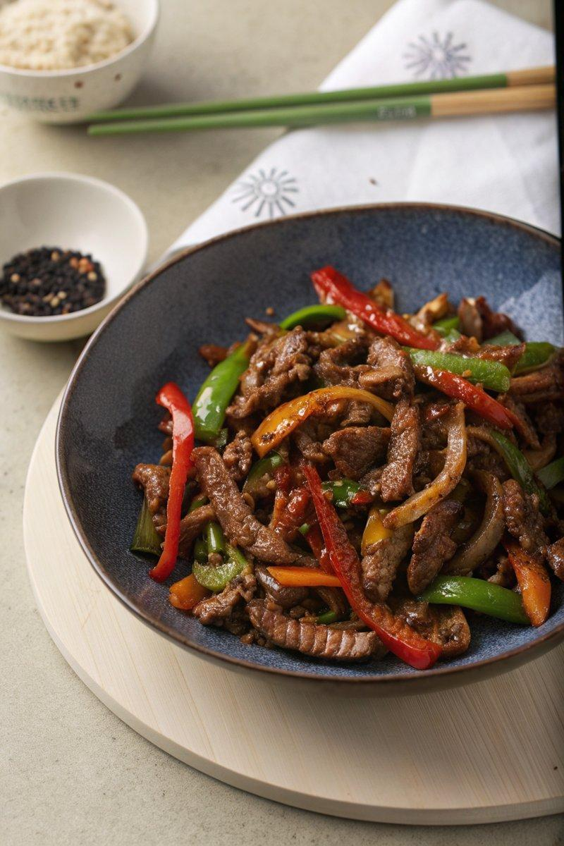

INGREDIENTS  - {'group': 'Main', 'item': '450g sirloin steak, sliced thinly against the grain'}  - {'group': 'Seasoning', 'item': '1/4 tsp salt'}  - {'group': 'Seasoning', 'item': '2 tsp ground black pepper'}  - {'group': 'Main', 'item': '4 tbsp sunflower oil'}  - {'group': 'Main', 'item': '1 tsp sesame oil'}  - {'group': 'Main', 'item': '2 onions, peeled and sliced thickly'}  - {'group': 'Main', 'item': '1 green bell pepper, deseeded and sliced'}  - {'group': 'Main', 'item': '1 red bell pepper, deseeded and sliced'}  - {'group': 'Sauce', 'item': '2 tbsp cornflour'}  - {'group': 'Sauce', 'item': '2 tbsp dark soy sauce'}  - {'group': 'Sauce', 'item': '2 tbsp oyster sauce'}  - {'group': 'Sauce', 'item': '1 tbsp Chinese rice wine or dry sherry'}  - {'group': 'Sauce', 'item': '120ml beef stock'}  - {'group': 'Main', 'item': '2 garlic cloves, minced'}  - {'group': 'Main', 'item': '1 tsp minced ginger'} | PREP  Slice the sirloin steak thinly against the grain. Peel and slice the onions into thick slices. Deseed and slice the green and red bell peppers. Mince the garlic and ginger.  COOK  Toss the steak slices with salt and 1 tsp of black pepper. Heat 3 tbsp of sunflower oil and sesame oil in a wok over high heat. Add the steak and stir-fry for 2-3 mins until browned. Remove the steak and set aside. Add the remaining sunflower oil to the wok, then stir-fry the onions and bell peppers for 3-4 mins until they start to soften. Mix cornflour, soy sauce, oyster sauce, and rice wine in a bowl. Add beef stock and remaining black pepper, stirring to combine. Add garlic and ginger to the wok, cooking for 1 min. Pour in the sauce, bring to a simmer, then return the steak to the wok, stirring to coat. Cook for an additional 2 mins.  PLATING  Serve the black pepper beef over cooked rice, ensuring each portion has a generous amount of sauce and vegetables.

NOTES:
For a variation, substitute the beef with thin strips of pork or chicken.

