CRISPY SPICED CHICKEN WITH CHILLIES AND ONIONS  COOK TIME: 20 mins  SOURCE: Unknown  #chicken #asian #pan-fry | 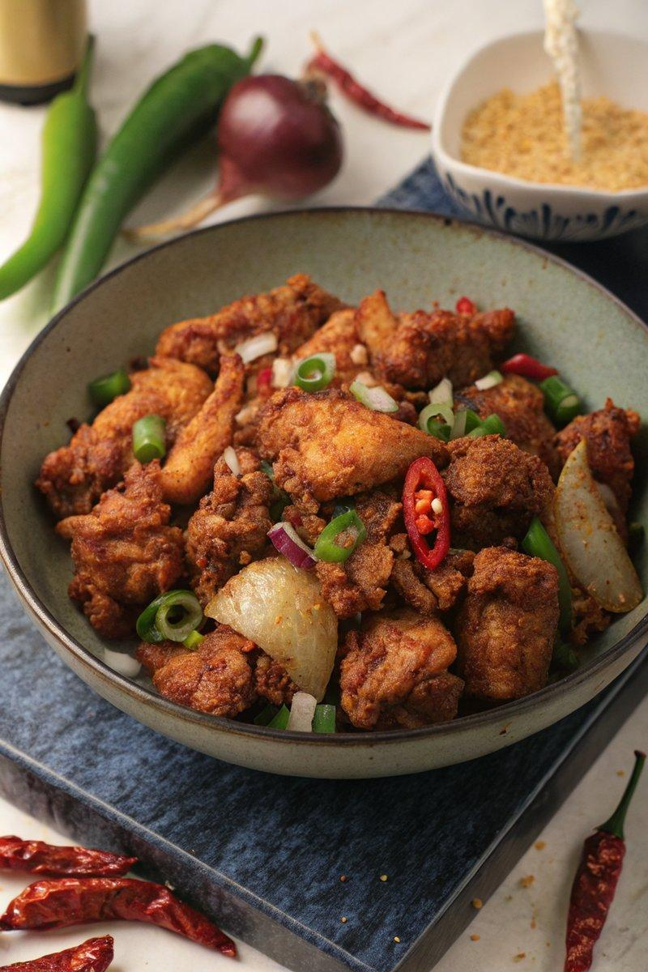

INGREDIENTS  - {'group': 'Main', 'item': '540g skinless chicken thigh fillets, quartered'}  - {'group': 'Seasoning', 'item': '60g cornflour'}  - {'group': 'Seasoning', 'item': '1 tbsp table salt'}  - {'group': 'Seasoning', 'item': '1 tbsp ground black pepper'}  - {'group': 'Seasoning', 'item': '1 tbsp Chinese five-spice'}  - {'group': 'Cooking', 'item': '240ml sunflower oil'}  - {'group': 'Vegetables', 'item': '1 large onion, chopped into large chunks'}  - {'group': 'Vegetables', 'item': '1 red chilli, chopped'}  - {'group': 'Vegetables', 'item': '1 green chilli, chopped'}  - {'group': 'Vegetables', 'item': '2 garlic cloves, minced'}  - {'group': 'Garnish', 'item': '3 spring onions, roughly chopped'} | PREP  Mix the cornflour, half of the salt, half of the black pepper, and the Chinese five-spice in a bowl. Coat the chicken thigh pieces thoroughly with this mixture.  COOK  Heat 230ml of sunflower oil in a large frying pan over high heat. Once hot, fry the chicken pieces in batches for 5-7 minutes, turning once, until golden brown and cooked through. Remove and drain on paper towels. In another pan, heat the remaining oil over medium-high heat. Sauté the onion, red and green chillies with the remaining salt and pepper for 2-3 minutes until the onion softens. Add the garlic and spring onions, cooking for an additional minute. Combine the cooked chicken with the sautéed vegetables, tossing to mix well.  PLATING  Serve the crispy chicken and vegetables hot, garnished with additional spring onions if desired.

NOTES:
Adjust the spice level by using different types of chillies. For a milder dish, substitute chillies with bell peppers.

