SESAME PRAWN TOAST  COOK TIME: 5 mins  SOURCE: Unknown  #prawns #asian #pan-fry | 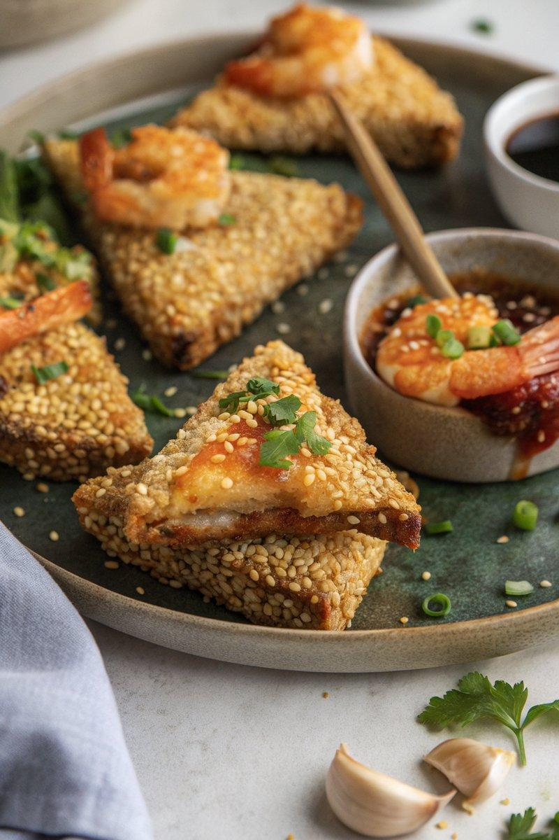

INGREDIENTS  - {'group': 'Main', 'item': '200g raw prawns, shelled and deveined'}  - {'group': 'Main', 'item': '1 tsp minced ginger'}  - {'group': 'Main', 'item': '2 garlic cloves, minced'}  - {'group': 'Main', 'item': '1 egg white'}  - {'group': 'Main', 'item': '2 spring onions, finely chopped'}  - {'group': 'Main', 'item': '1 tsp light soy sauce'}  - {'group': 'Main', 'item': '1/4 tsp salt'}  - {'group': 'Main', 'item': '1/8 tsp ground white pepper'}  - {'group': 'Main', 'item': '3 pieces of thick sliced white bread'}  - {'group': 'Main', 'item': '6 tbsp sesame seeds'}  - {'group': 'Main', 'item': 'Sunflower oil for frying, ~1L'}  - {'group': 'Garnish', 'item': '1 tbsp chopped fresh coriander'}  - {'group': 'For Serving', 'item': '2 tbsp sweet chilli sauce'} | PREP  In a food processor, combine the prawns, ginger, garlic, egg white, spring onions, soy sauce, salt, and white pepper. Blend until a smooth paste forms. Cut each slice of bread into four triangles.  COOK  Spread about 1 tbsp of prawn paste onto each bread triangle. Press the paste side into sesame seeds to coat. Heat sunflower oil in a wok over high heat. Fry the triangles, paste-side down, for 1-2 mins, then flip and cook for an additional 30-60 seconds until golden and cooked through.  PLATING  Drain the prawn toasts on paper towels to remove excess oil. Garnish with chopped coriander and serve with sweet chilli sauce.

NOTES:
For best results, fry in batches to maintain oil temperature. The prawn mixture can be prepared a few hours in advance and refrigerated until ready to use.

