VEGETABLE SPRING ROLLS  COOK TIME: 15 mins  SOURCE: Unknown  #vegetarian #asian #deep-fry | 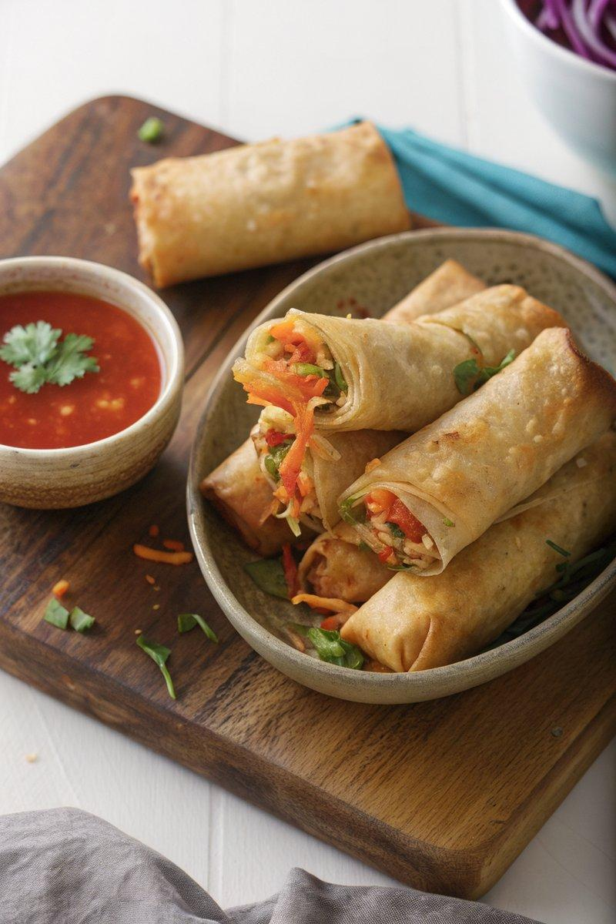

INGREDIENTS  - {'group': 'Main', 'item': '1 tbsp sunflower oil'}  - {'group': 'Main', 'item': '1 tbsp sesame oil'}  - {'group': 'Main', 'item': '2 carrots, peeled and sliced into matchsticks'}  - {'group': 'Main', 'item': '140g cabbage, thinly sliced'}  - {'group': 'Main', 'item': '1/2 red bell pepper, deseeded and thinly sliced'}  - {'group': 'Main', 'item': '140g beansprouts'}  - {'group': 'Main', 'item': '2 garlic cloves, minced'}  - {'group': 'Sauce', 'item': '4 tbsp light soy sauce'}  - {'group': 'Sauce', 'item': '2 tbsp hoisin sauce'}  - {'group': 'Seasoning', 'item': '1/4 tsp white pepper'}  - {'group': 'Slurry', 'item': '2 tsp cornflour mixed with 2 tbsp cold water'}  - {'group': 'For Frying', 'item': 'Oil, for deep frying'}  - {'group': 'Wrapper', 'item': '10 spring roll pastry wrappers'}  - {'group': 'For Serving', 'item': 'Sweet chilli sauce'} | PREP  Prepare the vegetables by slicing the carrots into matchsticks, thinly slicing the cabbage and red bell pepper, and mincing the garlic. Mix the cornflour with cold water to create a slurry.  COOK  Heat the sunflower and sesame oils in a wok over medium-high heat. Stir-fry the carrots, cabbage, and red pepper for 1 minute until slightly softened. Add the beansprouts and garlic, cooking for another minute. Stir in the soy sauce, hoisin sauce, and white pepper, then gradually add the cornflour slurry until the mixture is slightly sticky. Remove from heat and let cool. Heat oil in a pan for deep frying. Place a heaped tablespoon of the vegetable mixture on a spring roll wrapper, roll tightly, and seal with water. Repeat for all wrappers. Fry the rolls in batches for 2-3 minutes until golden brown.  PLATING  Drain the fried spring rolls on paper towels to remove excess oil. Serve hot with sweet chilli sauce for dipping.

NOTES:
To prevent the wrappers from drying out, cover them with a damp towel while assembling the rolls. For a non-vegetarian version, add cooked meat strips to the filling.

