CHEESY CHICKEN AND BACON PASTA BAKE  COOK TIME: 25 mins  SOURCE: Unknown  #chicken #Italian #bake | 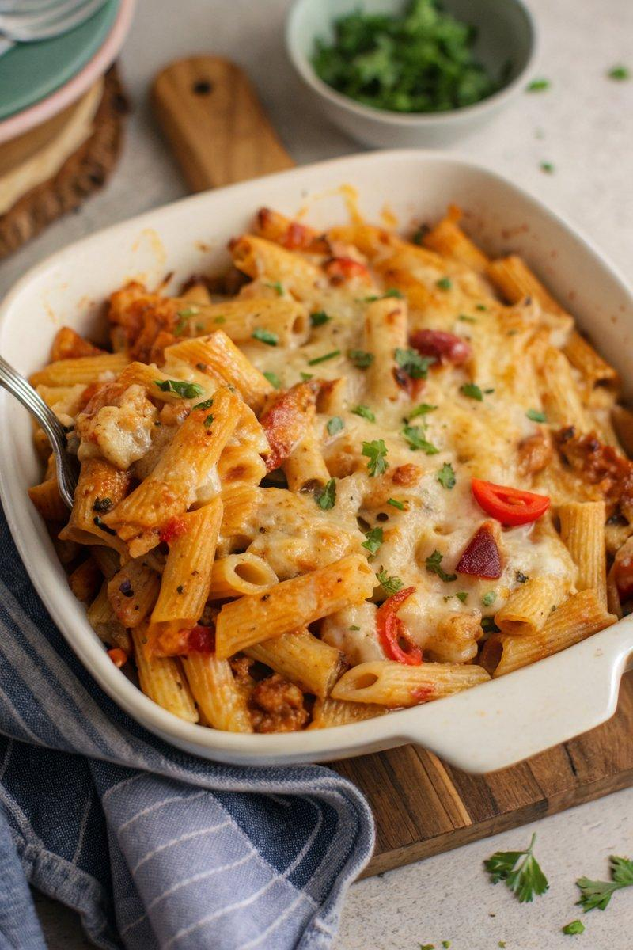

INGREDIENTS  - {'group': 'Main', 'item': '400g dried rigatoni pasta'}  - {'group': 'Main', 'item': '1 tbsp sunflower oil'}  - {'group': 'Main', 'item': '600g chicken breasts, cut into bite-size chunks'}  - {'group': 'Main', 'item': '1 large onion, chopped'}  - {'group': 'Main', 'item': '1 red bell pepper, chopped'}  - {'group': 'Main', 'item': '1 yellow bell pepper, chopped'}  - {'group': 'Main', 'item': '6 rashers cooked bacon, chopped'}  - {'group': 'Sauce', 'item': '2 garlic cloves, minced'}  - {'group': 'Sauce', 'item': '1 tbsp tomato purée'}  - {'group': 'Sauce', 'item': '1/2 tsp dried oregano'}  - {'group': 'Sauce', 'item': '1/2 tsp dried thyme'}  - {'group': 'Sauce', 'item': '2 x 400g cans chopped tomatoes'}  - {'group': 'Sauce', 'item': '120ml double cream'}  - {'group': 'Main', 'item': '100g baby spinach'}  - {'group': 'Topping', 'item': '100g grated mature Cheddar'}  - {'group': 'Topping', 'item': '100g grated mozzarella'}  - {'group': 'Garnish', 'item': 'Small bunch of flat-leaf parsley, torn'} | PREP  Preheat the oven to 190°C (375°F (190°C)). Bring a large pot of water to a boil and cook the rigatoni for 1 minute less than the package instructions. Drain and set aside.  COOK  Heat the sunflower oil in a large skillet over medium heat. Add the chicken pieces and sauté for about 5 minutes until just sealed. Add the chopped onion and cook for another 3-4 minutes until softened. Stir in the bell peppers, garlic, tomato purée, oregano, and thyme, cooking for 2-3 minutes. Pour in the chopped tomatoes and cream, bringing the mixture to a gentle simmer. Add the cooked pasta, spinach, and bacon, stirring to combine. Transfer everything to a large baking dish.  PLATING  Top the pasta mixture with grated Cheddar and mozzarella. Bake in the preheated oven for 20-25 minutes until the cheese is golden brown. Remove from the oven and garnish with torn parsley before serving.

NOTES:
For a vegetarian version, replace the chicken with zucchini or mushrooms and omit the bacon or substitute with vegetarian chorizo. Leftovers can be refrigerated and served cold or reheated in the microwave.

