TOMATO SALMON PASTA  COOK TIME: 15 mins  SOURCE: Unknown  #salmon #Italian #pasta | 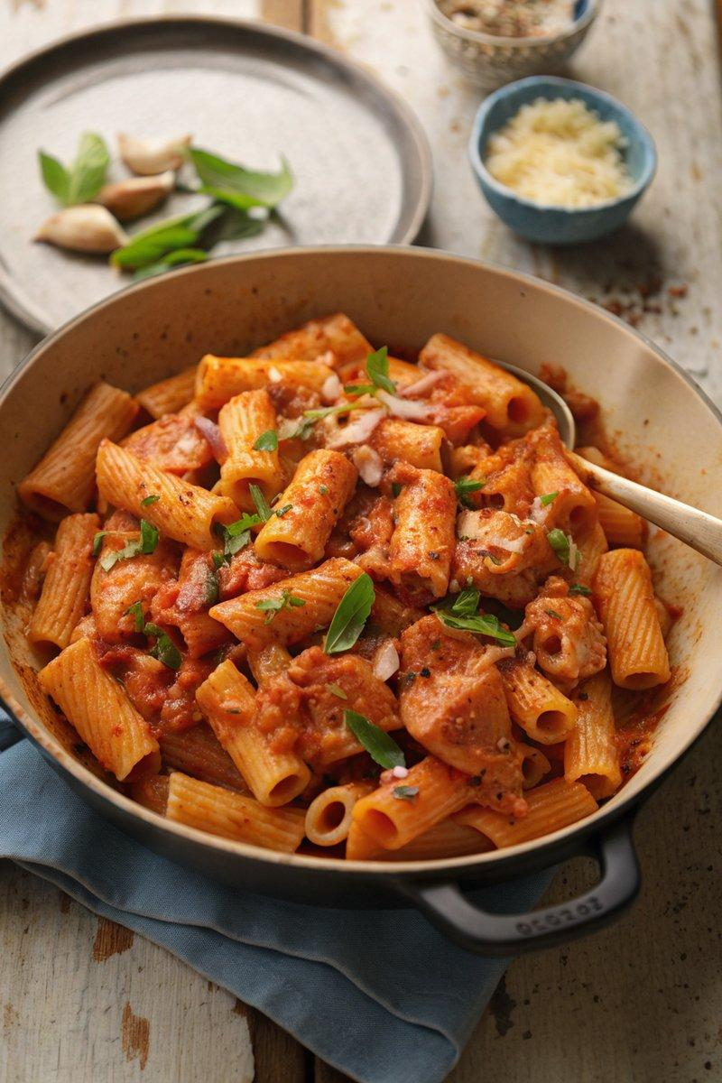

INGREDIENTS  - {'group': 'Main', 'item': '400g rigatoni'}  - {'group': 'Main', 'item': '3 skin-on salmon fillets (~400g)'}  - {'group': 'Main', 'item': '1 onion, finely diced'}  - {'group': 'Main', 'item': '2 garlic cloves, minced'}  - {'group': 'Sauce', 'item': '500g passata'}  - {'group': 'Sauce', 'item': '1 tbsp tomato purée'}  - {'group': 'Sauce', 'item': '1/2 tsp dried thyme'}  - {'group': 'Sauce', 'item': '1 tsp sugar'}  - {'group': 'Sauce', 'item': '3 tbsp double cream'}  - {'group': 'Seasoning', 'item': '1/4 tsp salt'}  - {'group': 'Seasoning', 'item': '1/4 tsp ground black pepper'}  - {'group': 'For Serving', 'item': 'grated Parmesan'}  - {'group': 'For Serving', 'item': 'fresh basil leaves'} | PREP  Dice the onion and mince the garlic. Season the salmon fillets with salt and pepper.  COOK  Cook the rigatoni according to package instructions, reserving 240ml of the cooking water. Heat olive oil in a large frying pan over medium-high heat. Place the salmon fillets skin-side up and fry for 3 minutes until golden. Flip the salmon, move to one side, and add the onion to the pan. Sauté for 3-4 minutes until softened, then add garlic and cook for 30 seconds. Stir in passata, tomato purée, thyme, and sugar, simmering for 2-3 minutes. Remove salmon skin, break the fish into chunks, and stir in cream. Add cooked pasta and a splash of reserved water, mixing to combine.  PLATING  Divide the pasta among bowls, topping with grated Parmesan, black pepper, and fresh basil leaves.

NOTES:
For a spicy kick, add a pinch of chilli flakes to the sauce.

