ROASTED VEGETABLE PESTO PASTA  COOK TIME: 30 mins  SOURCE: Unknown  #vegetarian #Italian #roast | 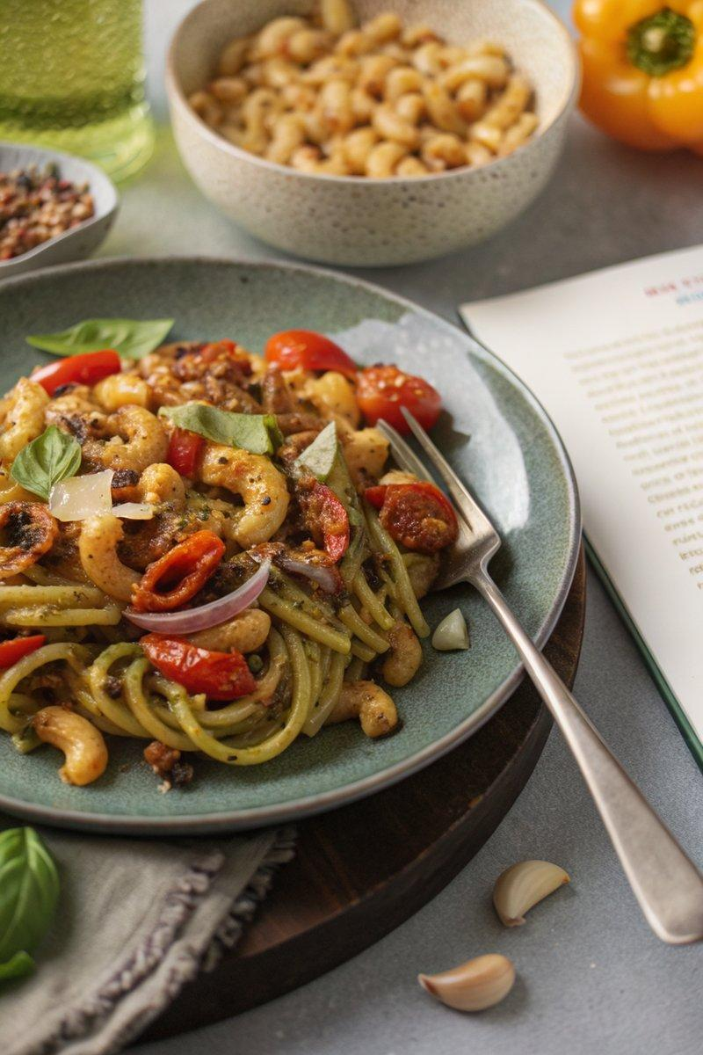

INGREDIENTS  - {'group': 'Main', 'item': '300g cherry tomatoes, sliced in half'}  - {'group': 'Main', 'item': '2 garlic cloves, peeled'}  - {'group': 'Main', 'item': '1 red onion, chopped into bite-size chunks'}  - {'group': 'Main', 'item': '1 courgette, chopped into bite-size chunks'}  - {'group': 'Main', 'item': '1 red bell pepper, sliced'}  - {'group': 'Main', 'item': '1 yellow bell pepper, sliced'}  - {'group': 'Main', 'item': '2 tbsp olive oil'}  - {'group': 'Main', 'item': '400g pasta shapes, such as spiralli'}  - {'group': 'Sauce', 'item': '3 tbsp pesto'}  - {'group': 'Sauce', 'item': '4 tbsp double cream'}  - {'group': 'Seasoning', 'item': '2 tsp cornflour'}  - {'group': 'Seasoning', 'item': '½ tsp salt'}  - {'group': 'Seasoning', 'item': '½ tsp ground black pepper'}  - {'group': 'Seasoning', 'item': '½ tsp paprika'}  - {'group': 'Garnish', 'item': 'A small bunch of basil leaves'}  - {'group': 'Garnish', 'item': '2 tbsp grated Parmesan'}  - {'group': 'Garnish', 'item': '1 tbsp toasted pine nuts'} | PREP  Preheat the oven to 200°C (400°F (200°C)). Slice the cherry tomatoes in half and chop the red onion and courgette into bite-size chunks. Slice the red and yellow peppers.  COOK  Place the cherry tomatoes in a large roasting dish and sprinkle with cornflour, salt, pepper, and paprika. Toss to coat. Add garlic, red onion, courgette, and peppers to the dish, drizzle with olive oil, and toss again. Roast in the oven for 20-25 mins until golden brown. Meanwhile, cook the pasta according to package instructions and drain. Once the vegetables are roasted, stir in the pesto and cream, and return to the oven for 2 mins to heat through.  PLATING  Combine the roasted vegetables and sauce with the cooked pasta, tossing to coat. Serve in bowls, garnished with fresh basil leaves, grated Parmesan, and toasted pine nuts.

NOTES:
To make this dish vegetarian, use vegetarian pesto and Italian-style hard cheese instead of Parmesan.

