SPICY BAKED SEA BASS WITH SWEET SOY GLAZE  COOK TIME: 8 mins  SOURCE: Unknown  #sea bass #asian #baked | 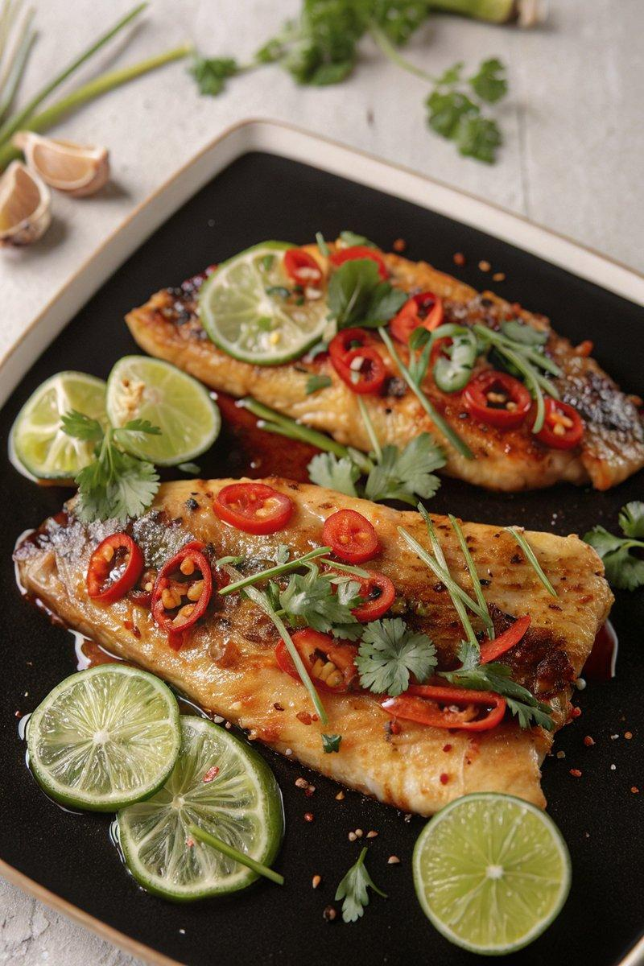

INGREDIENTS  - {'group': 'Main', 'item': '4 skin-on sea bass fillets'}  - {'group': 'Sauce', 'item': '2 tbsp sesame oil'}  - {'group': 'Sauce', 'item': '1 red chilli, finely chopped'}  - {'group': 'Sauce', 'item': '4 tbsp honey'}  - {'group': 'Sauce', 'item': '2 tbsp dark soy sauce'}  - {'group': 'Sauce', 'item': '1/2 tsp ground ginger'}  - {'group': 'Sauce', 'item': '2 garlic cloves, minced'}  - {'group': 'Sauce', 'item': '1 tbsp lime juice'}  - {'group': 'Main', 'item': '1/2 tsp cornflour'}  - {'group': 'Main', 'item': '2 tbsp light brown sugar'}  - {'group': 'Garnish', 'item': 'fresh coriander, torn'}  - {'group': 'Garnish', 'item': 'spring onions, sliced into thin strips'}  - {'group': 'Garnish', 'item': '1 red chilli, thinly sliced'}  - {'group': 'Garnish', 'item': 'slices of lime'} | PREP  Preheat the oven to 200°C (400°F (200°C)). In a small bowl, combine sesame oil, chopped red chilli, honey, dark soy sauce, ground ginger, minced garlic, and lime juice to create the sauce.  COOK  Place the sea bass fillets skin-side down on a baking tray. Sprinkle cornflour over the fillets and rub gently. Pour the prepared sauce over the fish, allowing some to run off. Sprinkle light brown sugar over the fillets. Bake in the oven for 8 minutes, basting with the sauce halfway through.  PLATING  Once cooked, remove the sea bass from the oven and baste again with the sauce. Garnish with torn coriander, sliced spring onions, and red chilli. Serve with lime slices on the side.

NOTES:
Using skin-on fillets helps the fish hold together and remain tender during cooking.

