SHAVED BRUSSELS SPROUTS SALAD WITH MINT AND WALNUTS  COOK TIME: 45 mins  SOURCE: Unknown  #vegetarian #American #bake | 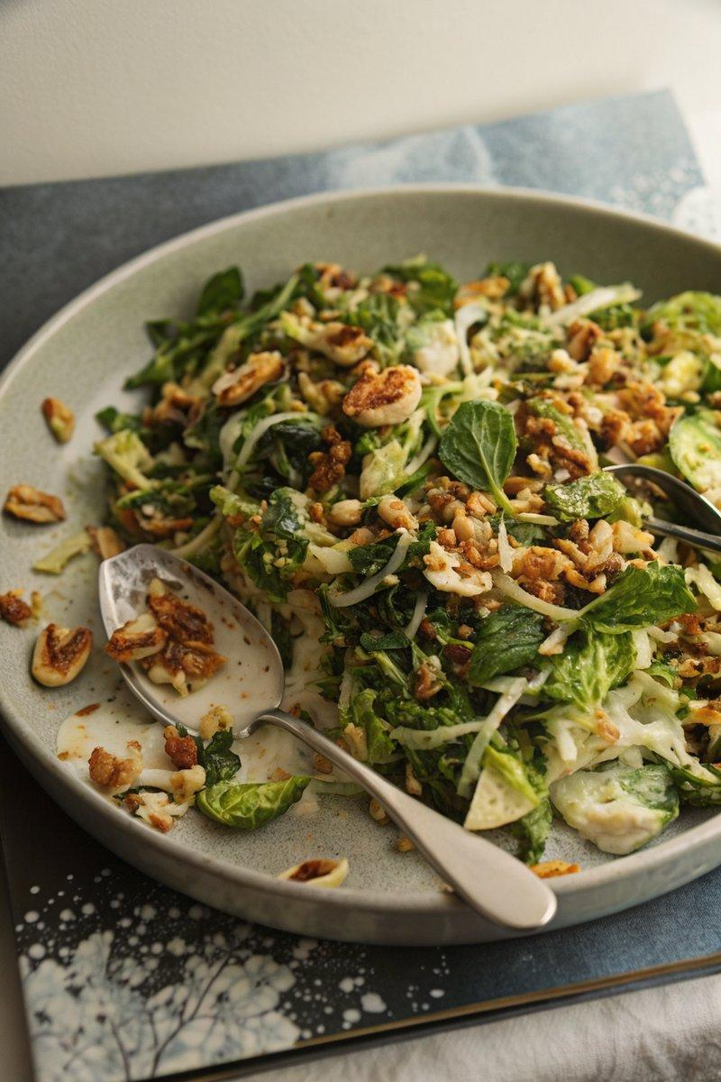

INGREDIENTS  - {'group': 'Main', 'item': '435g Brussels sprouts, trimmed and shredded'}  - {'group': 'Main', 'item': '50g walnuts, chopped'}  - {'group': 'Main', 'item': '240g crème fraiche'}  - {'group': 'Main', 'item': '24g scallions, thinly sliced'}  - {'group': 'Main', 'item': '2 tbsp mint leaves, chopped'}  - {'group': 'Main', 'item': '1 tsp red chili pepper flakes'}  - {'group': 'Dressing', 'item': '2 garlic cloves, puréed'}  - {'group': 'Dressing', 'item': '2 tbsp fresh lemon juice'}  - {'group': 'Dressing', 'item': '1 tsp ground black pepper'}  - {'group': 'Garnish', 'item': 'Crispy shallots'} | PREP  Trim the Brussels sprouts and slice them into fine shreds. Submerge in salted ice-cold water for 10 minutes. Meanwhile, purée the garlic cloves and prepare the dressing by mixing the garlic purée with crème fraiche, lemon juice, and black pepper.  COOK  Preheat the oven to 149°C (300°F (150°C)). Slice shallots thinly, toss with oil and salt, and bake on a parchment-lined sheet for 30-45 minutes until golden and crisp, stirring occasionally. Toast walnuts in a skillet over medium-low heat until aromatic, about 4-5 minutes.  PLATING  Drain the Brussels sprouts and pat dry. In a large bowl, combine the sprouts, scallions, walnuts, and half of the dressing. Transfer to a serving dish, garnish with mint, chili flakes, and crispy shallots. Serve with remaining dressing on the side.

NOTES:
The salad can be stored in an airtight container in the refrigerator for up to 2 days. Allow it to come to room temperature before serving.

