STICKY DATE PUDDING WITH RED DATE CARAMEL SAUCE  COOK TIME: 25 mins  SOURCE: Unknown  #dessert #asian #bake | 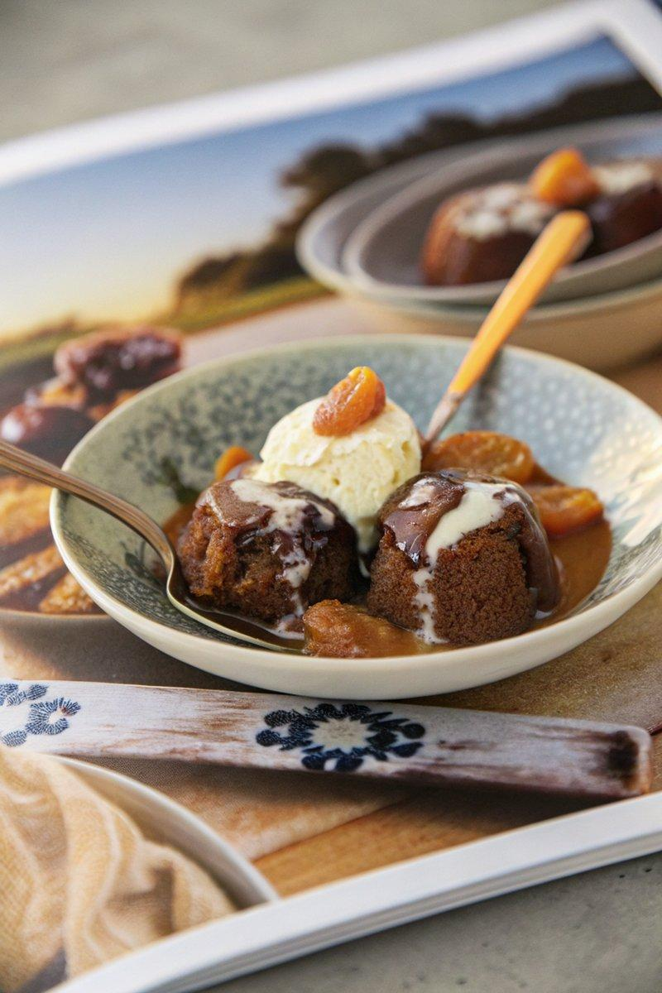

INGREDIENTS  - {'group': 'Main', 'item': '250g pitted dates, chopped'}  - {'group': 'Main', 'item': '1 tsp bicarbonate of soda'}  - {'group': 'Main', 'item': '125g unsalted butter, softened'}  - {'group': 'Main', 'item': '1 cup brown sugar'}  - {'group': 'Main', 'item': '1 tsp vanilla extract'}  - {'group': 'Main', 'item': '2 eggs'}  - {'group': 'Main', 'item': '1 3/4 cups self-raising flour'}  - {'group': 'For Serving', 'item': 'Vanilla bean ice-cream or coconut sorbet'}  - {'group': 'For Serving', 'item': '1 orange, cut into segments'}  - {'group': 'Red Date Caramel Sauce', 'item': '1/2 cup red dates, pitted'}  - {'group': 'Red Date Caramel Sauce', 'item': '1 cup brown sugar'}  - {'group': 'Red Date Caramel Sauce', 'item': '300ml coconut cream'}  - {'group': 'Red Date Caramel Sauce', 'item': '1/2 tsp vanilla extract'}  - {'group': 'Red Date Caramel Sauce', 'item': '60g unsalted butter'}  - {'group': 'Red Date Caramel Sauce', 'item': '2 tbsp orange juice'} | PREP  Preheat the oven to 180°C (160°C (320°F (160°C)) fan-forced). Grease and flour six 1-cup dariole moulds. Chop the dates and place them in a saucepan with 180ml water. Bring to a boil, then remove from heat and stir in the bicarbonate of soda. Let it sit for 15 minutes.  COOK  In a mixing bowl, cream the butter, brown sugar, and vanilla extract until pale and fluffy. Beat in the eggs one at a time. Fold in the date mixture and self-raising flour until just combined. Divide the batter among the prepared moulds and bake for 25 minutes, or until a skewer inserted into the centre comes out clean. For the caramel sauce, soak the red dates in boiling water for 30 minutes, then drain and puree in a food processor. In a saucepan, combine the date paste, brown sugar, coconut cream, vanilla extract, butter, and orange juice. Cook over medium heat until boiling, then reduce to a simmer for 2 minutes.  PLATING  Spoon a little caramel sauce into the bottom of each serving bowl. Place a turned-out pudding on top, drizzle with additional caramel sauce, and serve with a scoop of vanilla ice-cream or coconut sorbet and an orange segment.

NOTES:
The puddings and caramel sauce can be prepared ahead of time and reheated in the microwave before serving.

