SPINACH & "RICOTTA" CANNELLONI  COOK TIME: 30 min  SOURCE:  #comfort-food #pasta #vegetarian | 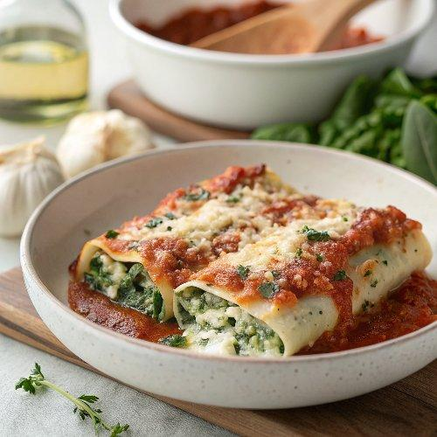

INGREDIENTS  - 1/2 tbsp oil  - 1 medium onion  - 2 large garlic cloves  - 7 oz fresh spinach (finely chopped)  - 1 batch (14 oz) vegan ricotta (*see notes)  - 21 oz tomato sauce (*see notes)  - 1/4 tsp nutmeg (or more to taste)  - 1/2 tsp onion powder  - Salt and black pepper (to taste)  - 14 tubes of dry cannelloni pasta (or Manicotti, gluten-free if needed (*see notes)  - 1 batch (7 oz) vegan cheese sauce (or store-bought vegan cheese) | PREP  COOK  1. First, prepare the vegan ricotta cheese (click for the recipe and instructions) for the homemade version or use store-bought vegan ricotta or vegan cream cheese.  2. Pour some tomato sauce in an 8x11-inch (20x28cm)es (20x28 cm) casserole/baking dish to avoid sticking and set aside.  3. Next, heat oil in a pan/skillet and sauté onion over medium heat. After a few minutes, add garlic, and spices. Also, add finely chopped spinach and sauté for a further 2-3 minutes.  4. Process the spinach mixture and vegan ricotta in a food processor (just pulse a couple of times). If you don't have a food processor or blender, simply add the vegan ricotta to the pan and stir with a wooden spoon. Turn off the heat and set aside. Preheat oven to 360 °F (ca. 180 °C).  5. Add the spinach and ricotta mixture into a piping bag and pipe the filling into the uncooked Cannelloni tubes (see step-by-step photos above in the blog post). Position the Cannelloni tubes upright, which makes it easier to fill them. You can also add the filling to a freezer bag and cut off one of the edges.  6. Then place all tubes into the casserole dish. Pour over the remaining tomato sauce, covering all the tubes. Add vegan cheese on top. I used my easy vegan cheese sauce but you can use any store-bought vegan cheese.  7. Bake for 30 minutes in the oven. I didn't use aluminum foil but if you notice after 15-20 minutes that it browns too much, simply cover the casserole dish with foil. Serve and garnish with fresh herbs. Enjoy! Store leftovers covered in the refrigerator for up to 3 days.  PLATING

