WARM PEARL COUSCOUS SALAD  COOK TIME: 17 min  SOURCE:  #healthy #quick #comfort-food | 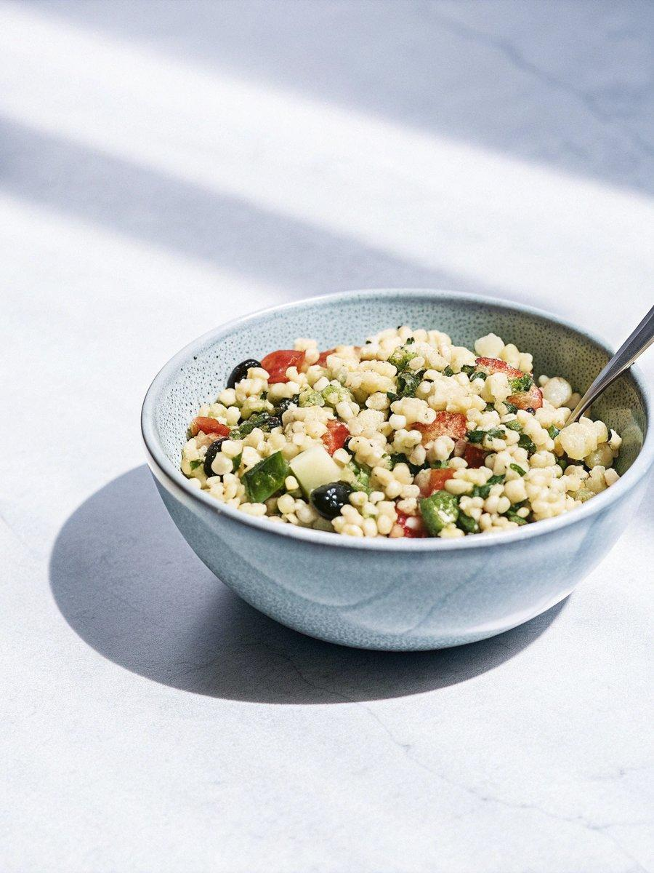

INGREDIENTS  - 1 cup (240ml) pearl couscous  - olive oil  - 2 cup (480ml) cooked chickpeas  - 2 cup (480ml) cherry tomatoes  - 1/2 tsp salt  - 1/4 tsp ground black pepper  - 1/2 cucumber  - 1/4 cup black olives  - 3 Tbsp fresh mint leaves  - 3 Tbsp fresh basil leaves  - 2 Tbsp fresh parsley  - 1/4 cup unsalted roasted almonds  - 3 Tbsp extra-virgin olive oil  - 3 Tbsp red wine vinegar  - 1/2 lemon  - 1/4 tsp sweet paprika powder | PREP  COOK  1. Cook the couscous according to the package instructions, then drain.  2. Meanwhile, drizzle oil in a medium pan over medium-high heat. When hot, add the chickpeas, tomatoes, salt, and pepper. Cook for 5 - 7 minutes, stirring occasionally. Remove from the heat.  3. In a small bowl, mix together the ingredients for the dressing.  4. To a large bowl, add the drained couscous, tomato and chickpea mixture, cucumber slices, olives, and fresh herbs. Add the dressing, toss to combine, spinkle over the almonds, and enjoy!  PLATING

