SICILIAN SQUASH & CHICKPEA STEW  COOK TIME: 1h 25m  SOURCE:  #comfort-food #healthy #stew | 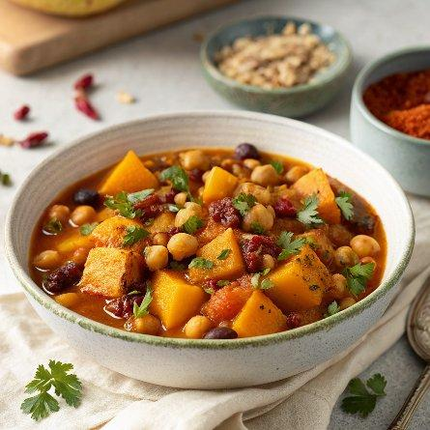

INGREDIENTS  - 1 butternut squash (roughly 1.2 kg)  - olive oil  - 2 onions  - 1/2 a bunch of fresh coriander (15 g)  - 40 g raisins  - 1 tsp ground cinnamon  - 1/2–1 tsp dried chilli flakes  - 50 g mixed olives, stone in  - 1 x 400 g tin of chopped tomatoes  - 1 x 400 g tin of chickpeas  - 1 vegetable stock cube  - 1 mug (320 g) of couscous  - fat-free natural yoghurt, to serve | PREP  COOK  PLATING

