PUMPKIN CRUMB COFFEE CAKE  COOK TIME: 35 min  SOURCE:  #comfort-food #baking #seasonal | 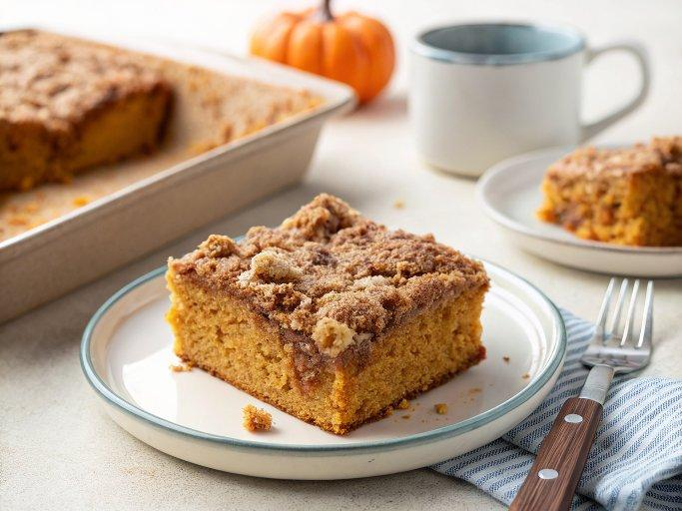

INGREDIENTS  - 1/2 cup (63 g) all-purpose flour (spooned & leveled)  - 1/2 cup (100 g) packed light or dark brown sugar  - 1 and 1/2 tsp ground cinnamon  - 1/4 cup (4 tbsp; 56 g) unsalted butter, cold  - 2 cup (480ml)s (250 g) all-purpose flour (spooned & leveled)  - 1 tsp baking soda  - 1/2 tsp baking powder  - 1/2 tsp salt  - 1 and 1/2 tsp ground cinnamon  - 1/2 tsp ground nutmeg*  - 1/4 tsp ground cloves*  - 1/4 tsp ground ginger*  - 1 cup (226 g) pumpkin puree  - 1/2 cup (100 g) packed light or dark brown sugar  - 1/2 cup (120 ml) canola or vegetable oil (or melted coconut oil if you prefer)  - 1/4 cup (82 g) pure maple syrup  - 1/4 cup (60 ml) milk*  - 1 cup (120 g) confectioners’ sugar  - 2 tbsp pumpkin spice coffee creamer, half-and-half, or milk  - 1/4 tsp pure vanilla extract | PREP  COOK  1. Preheat the oven to 350°F (177°C). Grease a 9-inch (23cm) square or 9-inch (23cm) springform baking pan (or any 2.5 quart baking dish) with nonstick spray. Set aside.  2. Make the crumb topping first  3. In a medium bowl, whisk the flour, brown sugar, and cinnamon together. Cut in the cold butter using a pastry blender or a fork. Mix to create clumps and crumbs. Set aside.  4. Make the cake  5. Whisk the flour, baking soda, baking powder, salt, cinnamon, nutmeg, cloves, and ginger together in a large bowl until combined. In a medium bowl, whisk the pumpkin, brown sugar, oil, maple syrup, and milk together until combined. Pour the wet ingredients into the dry ingredients and stir until *just* combined. Avoid over-mixing the batter. Batter will be very thick. Spoon/pour the batter into the prepared baking pan. Spread to make an even surface. Pour the crumb topping evenly on top and gently press them down into the batter.  6. Bake the cake for 30-35 minutes. Check the cake’s doneness at the 30 minute mark by inserting a toothpick into the center. If the toothpick comes out clean or with a couple moist crumbs, the cake is done. If the toothpick has wet batter on it, bake the cake for 5 more minutes or until the toothpick comes out clean.  7. Make the icing  8. Whisk the icing ingredients together. Add an extra splash of creamer/milk to thin out if desired. Drizzle over warm or cooled cake. (We like serving this warm.)  9. Cover leftover cake tightly and store at room temperature or in the refrigerator for up to 3 days.  PLATING

