VEGAN INSTANT POT LASAGNA (FROM THE VEGAN INSTANT POT COOKBOOK)  COOK TIME: 30 min  SOURCE:  #comfort-food #quick #one-pot | 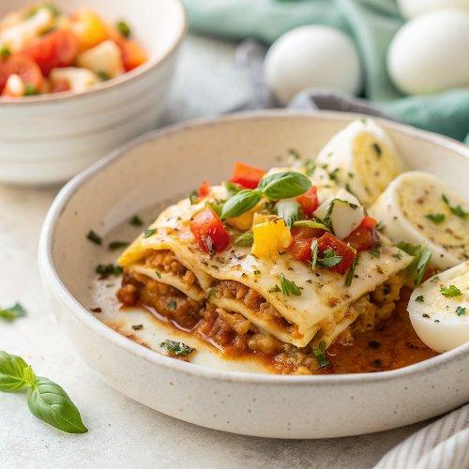

INGREDIENTS  - 2 tbsp olive oil  - 1 small yellow onion, (diced)  - 4 garlic cloves, (minced)  - 1 cup (240ml) finely chopped zucchini  - 3/4 cup finely chopped red bell pepper  - 1 cup (240ml) chopped mushrooms  - 1/3 cup fresh basil leaves (chopped, plus more for garnish)  - 1 tsp kosher salt Freshly cracked black pepper  - 1 1/2 cups marinara sauce of choice (or Fiery Arrabbiata Sauce (recipe in my cookbook, The Vegan Instant Pot Cookbook)  - 6 to 8 individual no-boil or oven-ready lasagna sheets  - Basil Ricotta (recipe follows), or 2 cups (480ml) shredded vegan mozzarella or other cheese)  - 1 cup (240ml) chopped spinach or shredded Tuscan (lacinato) kale)  - 1/2 cup shredded vegan mozzarella, (for finishing (optional)  - 1 14-oz block extra-firm tofu  - 1/4 cup nutritional yeast  - 2 garlic cloves, (roughly chopped)  - 2 tbsp white or yellow miso paste  - 3 ⁄4 tsp onion powder  - 1 tsp kosher salt, (plus more to taste)  - 1/2 tsp freshly cracked black pepper  - 1 tbsp extra-virgin olive oil  - 15 fresh basil leaves  - 1 1/2 tsp grated lemon zest  - 3 tbsp fresh lemon juice | PREP  COOK  1. Make the Basil Ricotta: Drain the tofu and blot away the excess water with a few paper towels. For a smooth ricotta, crumble the tofu into a food processor. Add the remaining ingredients and blend until you have a creamy, smooth texture. Taste for salt, acidity, and cheesiness, adding more salt, lemon juice, or nutritional yeast, respectively, as needed. For a chunkier ricotta, place the tofu in a large bowl and break it into smaller chunks using a fork. Add the remaining ingredients and mix together until the consistency resembles ricotta cheese.  2. Make the vegetable filling: Select the Sauté setting on the Instant Pot and, after a few minutes, add the olive oil, followed by the onion. Cook the onion for 3 minutes, then add the garlic, zucchini, bell pepper, and mushrooms. Cook for an additional 3 minutes, tossing frequently to prevent the garlic from burning.  3. Add the basil, salt, and pepper to taste. Stir to combine and cook for 30 seconds. Select the Cancel setting and remove the inner pot.  4. To assemble the lasagna: Pour the marinara sauce into a large measuring cup and add 1⁄2 cup (480ml) water to equal 2 cups (480ml), stirring to incorporate (thinning out the sauce with water ensures the noodles will cook evenly).  5. Pour 1⁄2 cup (480ml) of the marinara sauce into the bottom of a 7-inch (18cm) springform pan, spreading evenly with a silicone spatula. Top the sauce with half of the oven-ready lasagna noodles, breaking them into pieces and fitting them to cover the sauce in a mosaic-like pattern.  6. Add another 1⁄2 cup (480ml) of the marinara sauce on top of the noodles. Using a silicone spatula, spread one-third of the basil ricotta (or shredded cheese) on top of the marinara sauce, followed by half of the vegetable filling and half of the spinach or kale.  7. Repeat the layers: Add 1⁄2 cup (480ml) of the marinara sauce, followed by one-third of the basil ricotta (or shredded cheese), the remaining vegetable filling, and the remaining spinach or kale.  8. Finish with the remaining lasagna noodles (broken into pieces), the final 1⁄2 cup (480ml) marinara sauce, and the final one-third of the basil ricotta (or shredded cheese). If you can’t fit all of the lasagna noodles, just leave a few pieces out. You don’t want to layer them on top of each other because that might cause them to cook unevenly.  9. Spray a piece of foil with nonstick cooking spray and tightly cover the pan. Wipe out the inner pot of any remaining vegetables and give it a rinse. Add 11⁄2 cups (480ml) water to the inner pot.  1  0. For easy removal of the pan from the Instant Pot, create a foil sling (instructions are in my cookbook or can be found here).  1  1. On the counter, place the pan on top of the steamer rack (with the handles facing up) and arrange the foil sling (if using) underneath the steamer rack. Carefully lower the steamer rack and pan into the inner pot using the foil sling or steamer rack handles.  1  2. Secure the lid and set the Pressure Release to Sealing. Select the Pressure Cook setting at high pressure and set the cook time to 20 minutes. Allow a natural pressure release. If you want to broil the lasagna in your oven, turn on your oven’s broiler.  1  3. Open the pot and, wearing oven mitts, grasp the foil sling or steamer rack handles and carefully lift the pan out of the Instant Pot. Carefully remove the foil cover, taking care to not drip any condensation on the lasagna.  1  4. If desired, top the lasagna with the 1⁄2 cup (480ml) shredded vegan mozzarella and place the lasagna under the broiler for 1 to 3 minutes (depending on the strength of your broiler and the distance between the heat and oven rack) to brown the top. You can also broil the lasagna without adding the vegan mozzarella. Garnish with fresh basil.  PLATING

