SPICY SICHUAN PORK NOODLES  COOK TIME: 18 min  SOURCE:  #spicy #noodles #comfort-food | 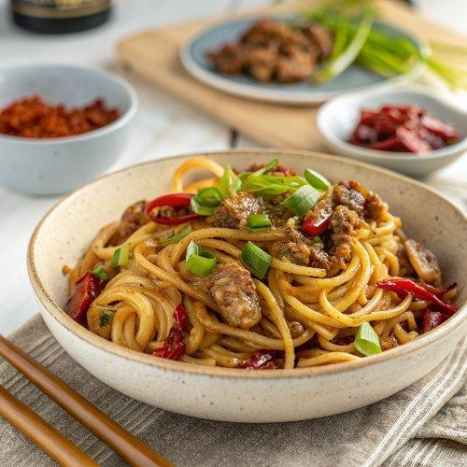

INGREDIENTS  - 1 1/2 tbsp oyster sauce  - 1 1/2 tbsp kecap manis*  - 4 tsp sambal oelek*  - 250 g fresh Shanghai or hokkien noodles  - 2 tbsp vegetable oil  - 2 cup (480ml)s (200 g) green beans, ends trimmed and cut in half  - 1/2 brown onion, finely diced  - 1 garlic clove*, finely minced  - 2 tsp finely minced ginger* (optional)  - 200 g pork mince | PREP  COOK  1. Spicy Asian sauce – Mix the ingredients in a small bowl.  2. Cook noodles – Cook the noodles according to the packet directions. Drain, then rinse briefly under tap water. Leave in the colander until ready to use.  3. Char beans – Heat 1 tablespoon of the oil in a large cast-iron frying pan over high heat until it is almost smoking. Add the green beans, spreading them out in a single layer. Leave to cook for 2 minutes, stirring only every 30 seconds, until lightly charred and just cooked through. Tip the beans into a bowl and set aside.  4. Cook pork – Cool the frying pan for 15 seconds, then place it back over high heat. Heat the remaining 1 tablespoon of oil, then cook the onion, garlic and ginger (if using) for 30 seconds. Add the pork mince and cook, breaking it up with a wooden spoon until it mostly changes from pink to white, about 1 minute. Add 1 tablespoon of the sauce and continue cooking the pork for another 1 minute until it is nicely browned.  5. Add the noodles, green beans and remaining sauce. Toss for 2 minutes with two wooden spoons, ensuring that the noodles get some nice caramelisation.  6. Serve – Divide between two bowls and devour!  PLATING

