CRISPY PORK MASSAMAN RAMEN  COOK TIME: 25 min  SOURCE:  #comfort-food #noodles #spicy | 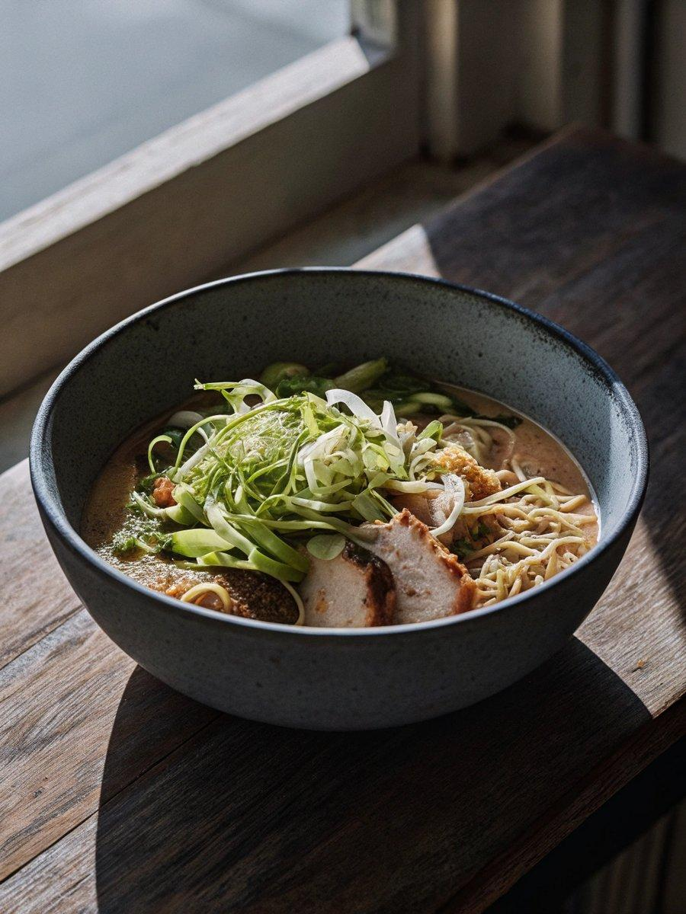

INGREDIENTS  - 150 g dried ramen noodles  - 5 tbsp sesame oil  - 2 spring onions finely sliced  - 3 garlic cloves finely chopped  - 1 red pepper deseeded and sliced  - 4 tbsp soy sauce  - 1-2 tbsp massaman curry paste  - 400ml (1.7 cups) can coconut milk  - 300 g pork mince  - 2 tsp Chinese five-spice powder  - chilli oil  - lime wedges | PREP  COOK  1. Cook the noodles following pack instructions, then drain well and rinse with cold water to prevent them from sticking. Divide the noodles between two bowls.  2. Drizzle 2 tbsp sesame oil into a saucepan over a medium heat. Mix in half of the spring onions and all the garlic. After 2-3 mins, add the red pepper and cook for an additional 5 mins. Once the veg has softened slightly, add 2 tbsp soy sauce and the massaman paste (start with 1 tbsp and adjust to taste). Cook for 2 mins, then pour in the coconut milk and simmer for 10 mins.  3. Meanwhile, heat the remaining oil in a non-stick frying pan over a medium-high heat and add the pork mince. Break the mince up to ensure even browning and after 3-4 mins, once most of the liquid has evaporated, stir in the five-spice powder and remaining soy sauce. Fry for 8-10 mins until it begins to brown and go slightly crispy.  4. Add a generous ladle of the ramen broth to the noodle bowls and top with the crispy pork and remaining spring onions. Serve with chilli oil and lime wedges.  PLATING

