EASY BAKED SCALLOPS RECIPE  COOK TIME: 5 min  SOURCE:  #seafood #baked #comfort-food | 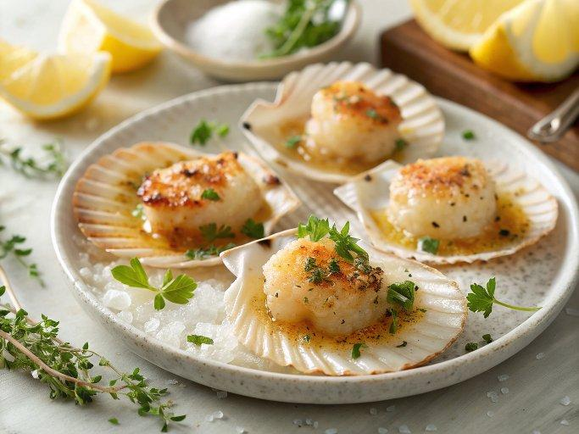

INGREDIENTS  - 24 scallops in shells  - 1 sprig fresh thyme  - 1/2 cup dry white wine  - 1/2 onion (chopped)  - 1/2 cup fresh parsley (finely chopped)  - 10 oz unsalted butter (softened)  - 1/3 cup garlic (minced)  - 1 tsp fine salt  - 1 cup (240ml) breadcrumbs  - 1 tsp black pepper | PREP  COOK  1. Preheat oven to 450°F (230°C).  2. Make garlic parsley butter: mix softened butter, parsley, garlic, salt, and breadcrumbs in a bowl until combined.  3. In a saucepan, combine white wine, onion, thyme, and pepper. Simmer briefly to blend flavours.  4. Place scallops (in shells) on a baking tray lined with parchment. Spoon a little of the wine-onion mixture over each.  5. Top each scallop with garlic parsley butter.  6. Bake in oven for 4–5 minutes until golden and bubbling.  7. Serve immediately hot, as an appetiser or with salad.  PLATING

