DEVILED EGGS  COOK TIME: 20 min  SOURCE:  #quick #comfort-food #party-food | 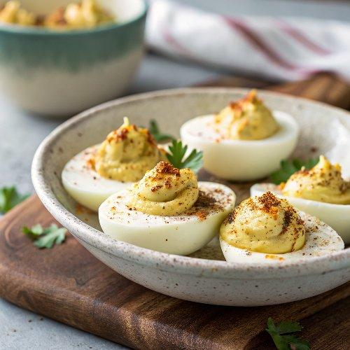

INGREDIENTS  - 6 large eggs  - 3 tbsp mayonnaise, (best quality such as Hellman’s or Duke’s)  - 1 1/2 tsp cider vinegar  - 1 tsp whole grain mustard  - 1/4 tsp Worcestershire sauce  - 1/8 tsp salt  - 1/8 tsp freshly ground black pepper  - 1/8 tsp sugar  - Pinch cayenne pepper  - 1 tbsp finely chopped mixed herbs, (such as chives, parsley, dill or tarragon, plus more for serving)  - Paprika, (for serving) | PREP  COOK  1. Place the eggs in a medium saucepan and fill the pan with enough water so that it covers the eggs by about an inch. Over high heat, bring the water to a full rolling boil—big, vigorous bubbles should be breaking all over the surface—then remove the pan from the heat, cover, and let stand for 10 minutes. Place the hard-boiled eggs in a bowl of cold water to cool (I usually just use the saucepan).  2. Once cool, tap each egg on the counter to crack the shell, then peel under cold running water. Slice the eggs in half lengthwise. Using a small spoon, gently remove the yolks and place them in a small bowl. Arrange the whites on a serving platter, gently wiping them clean if necessary. Using a spatula, push the egg yolks through a mesh sieve, then mash with the mayonnaise, vinegar, mustard, Worcestershire sauce, salt, black pepper, sugar, cayenne pepper, and herbs. (Passing the yolks through a sieve makes them much easier to mash without getting lumps but if you don’t want to bother, you can mix the yolks with the other filling ingredients - minus the herbs - in a food processor.) Taste and adjust seasoning, if necessary.  3. Fill a piping bag fitted with an open star or large plain tip with the yolk mixture. (Alternatively, fill a sealable plastic bag with the yolk mixture, and use your hand to gently push the mixture to one corner of the bag. Use scissors to snip off the tip of the corner, opening up a ¼–in [6-mm] hole.) Pipe the yolk mixture evenly into the egg white halves. (For a less fussy preparation, simply spoon the yolk mixture into the egg whites.) Sprinkle with paprika and more fresh herbs.  PLATING

