SPAGHETTI SAUCE  COOK TIME: 1h 10m  SOURCE:  #comfort-food #quick #homemade | 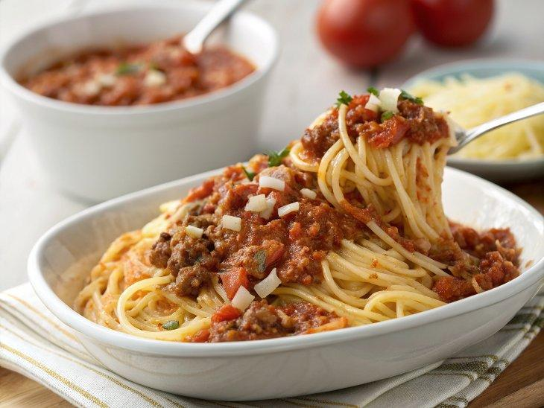

INGREDIENTS  - 1 tbsp olive oil  - 1 lb ground beef (450 g)  - 1 medium onion (chopped)  - 6 garlic cloves (minced)  - 2 (14.5-oz/411 g) cans diced tomatoes  - 1 (15-oz/425 g) can tomato sauce  - 1 (6-oz/170 g) can tomato paste  - 1 dried bay leaf  - 1 tbsp dried basil  - 1 tbsp dried oregano  - 2 tsp sugar  - 1 tsp salt  - 1/2 tsp ground black pepper  - 1/4 tsp red pepper flakes (optional)  - 1 tbsp chopped fresh parsley  - Fresh basil leaves (optional) | PREP  COOK  1. In a large deep skillet, heat oil over medium-high. Add the ground beef and onions. Cook, stirring often, until the beef is browned and crumbly and the onion is tender, about 5 minutes. Add the garlic and cook, stirring constantly, until fragrant, about 30 seconds.  2. Stir in the diced tomatoes, tomato sauce, tomato paste, bay leaf, dried basil, dried oregano, sugar, salt, pepper, and red pepper flakes if using. Bring to a simmer.  3. Reduce the heat to low, and continue cooking, stirring occasionally, until thickened, about 1 hour.  4. Remove and discard the bay leaf. Stir in chopped parsley and fresh basil, if desired. Serve over cooked spaghetti noodles, or let the sauce cool to room temperature before storing in an airtight container. The sauce will keep refrigerated for up to 5 days or frozen for up to 6 months.  PLATING

