WHISKEY SOUR  COOK TIME: 5 min  SOURCE:  #cocktail #refreshing #classic | 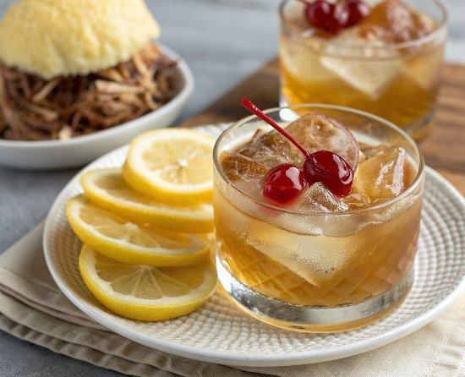

INGREDIENTS  - 2 oz bourbon (60 mL)  - 3/4 oz fresh lemon juice (22 mL)  - 1/2 oz simple syrup (15 mL)  - 1/2 oz egg white (14 g, optional)  - lemon peel  - maraschino cherry | PREP  COOK  1. Pour the bourbon, fresh lemon juice, simple syrup, and egg white into a cocktail shaker.  2. Close and shake vigorously.  3. Strain the drink into a coupe glass.  4. Garnish with lemon peel and maraschino cherry.  PLATING

