ASIAN SLAW  COOK TIME: 1 min  SOURCE:  #fresh #healthy #quick | 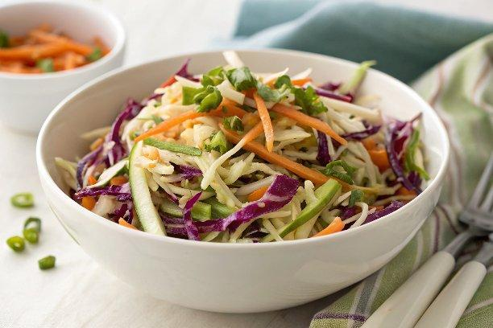

INGREDIENTS  - 3 cups (720ml) green cabbage (shredded)  - 1 cup (240ml) purple cabbage (shredded)  - 1 cup (240ml) carrots (shredded)  - 3/4 cup bell peppers (thinly sliced, red, yellow or a combination of colors)  - 1/4 cup sliced green onions (plus more for garnish if desired)  - 1/4 cup cilantro leaves (coarsely chopped, plus more for garnish if desired)  - 1/2 cup sliced almonds (toasted)  - 2 tsp sesame seeds  - 2 tbsp vegetable oil  - 1/4 cup rice vinegar  - 1/4 cup hoisin sauce  - 1 tsp honey  - 1 tbsp soy sauce  - 1 tsp fresh ginger (finely grated)  - 1 tbsp toasted sesame oil  - salt and pepper to taste | PREP  COOK  1. Place the green cabbage, purple cabbage, carrots, bell peppers, green onions, cilantro and almonds in a large bowl.  2. Combine all dressing ingredients in a small bowl; whisk until well combined.  3. Pour the dressing over the cabbage mixture. Toss to coat evenly. Sprinkle the sesame seeds over the slaw.  4. Garnish with additional green onions and cilantro if desired, then serve immediately, or refrigerate for up to 4 hours.  PLATING

