GOOEY CHOCOLATE ROLLS  COOK TIME: 22 min  SOURCE:  #comfort-food #baking #sweet | 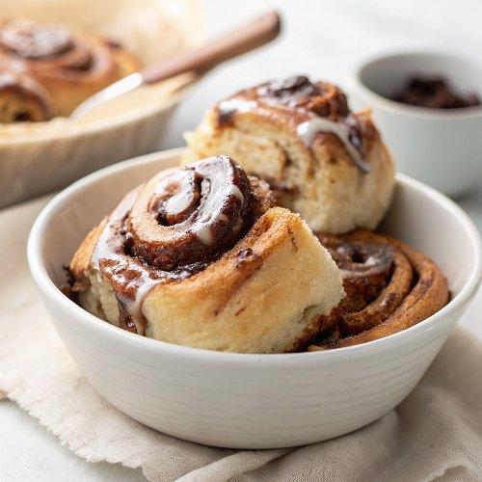

INGREDIENTS  - 1 cup (237 g) whole milk  - 1 stick (113 g) unsalted butter  - 1/4 cup (57 g) sour cream, (at room temperature)  - 1 envelope (2 1/4 tsp) instant yeast*  - 1/4 cup (50 g) granulated sugar  - 1 large egg, (at room temperature)  - 2 egg yolks, (at room temperature)  - 1/2 tsp vanilla extract  - 4 to 4 1/4 cups (508 to 540 g) all-purpose flour, (plus more for dusting)  - 1 1/2 tsp fine sea salt  - 10 tbsp (142 g) unsalted butter, (completely softened to room temperature)  - 2/3 cup (133 g) packed light brown sugar  - 1/3 cup (28 g) unsweetened cocoa powder  - 1/8 tsp fine sea salt  - 1 1/2 cups (188 g) powdered sugar, (sifted)  - 1/4 cup (21 g) unsweetened cocoa powder, (sifted)  - 1/4 cup (49 g) whole milk  - 2 tbsp (28 g) unsalted butter, (melted)  - 1 tsp vanilla extract | PREP  COOK  1. Make the dough:  2. In a small saucepan, heat the milk and butter until the butter is melted. Remove from heat and stir in the sour cream until smooth. Let cool until lukewarm (about 100°F - 110°F).**  3. In the bowl of an electric mixer, use a spatula to combine the milk mixture with the yeast, sugar, egg, egg yolks, and vanilla until well combined. Add in half of the flour and the salt and stir with the spatula until combined. Fit the mixer with the dough hook and gradually add the remaining flour until a dough begins to form. Only add as much flour as you need to form the dough. Knead at medium speed until the dough is very soft, smooth, pliable, elastic, and doesn’t stick to the sides of the bowl, about 8 to 10 minutes. If the dough is unbearably sticky, add more flour 1 tablespoon at a time. Only add as much flour as needed to create a smooth dough.  4. Lightly grease a large bowl. Shape the dough into a ball and place in the greased bowl. Cover with plastic wrap and let rise in a warm place until doubled in size, about 1 1/2 to 2 hours.  5. Make the filling:  6. While the dough rises, add filling ingredients to a medium mixing bowl. Beat with an electric mixer on medium-high until very well combined, about 3 minutes.  7. Shape the dough:  8. Punch down the risen dough and turn out onto a lightly floured work surface. Use a rolling pin to shape the dough into a 16x12-inch (41x30cm) rectangle, with the long side facing you.  9. Spread the filling mixture all over the dough, leaving a 1/2-inch (5cm) border at the far edge. Brush the border with water to help seal.  1  0. Roll up the dough, pulling with your hands to keep it tightly rolled until it’s an even log shape. Press the border to seal. Trim the edges.  1  1. Grease a 13x9-inch (33x23cm) baking dish or two 9-inch (23cm) pie pans. Cut the roll into 12 equal pieces using a sharp serrated knife or unflavored dental floss. Place the rolls cut side up in the prepared baking dish. Cover with plastic wrap and let rise in a warm place until doubled, about 1 1/2 to 2 hours.  1  2. Make Ahead: Allow the shaped rolls to rise until they’ve grown in size by about 25%. Cover the baking dish well with plastic wrap and refrigerate for up to 24 hours. Allow to come completely to room temperature and continue to rise until doubled in size, about 2 hours, before baking as directed below.  1  3. Meanwhile, preheat the oven to 350°F (175°C). Bake the rolls until lightly golden brown, 20 to 22 minutes.  1  4. Make the icing:  1  5. While the rolls bake, combine the icing ingredients in a small mixing bowl until a smooth pourable icing forms.  1  6. Spread over hot rolls immediately after they come out of the oven. Serve warm the day they’re baked.  PLATING

