THAI RED FISH CURRY NOODLES.  COOK TIME: 15 min  SOURCE:  #quick #comfort-food #spicy | 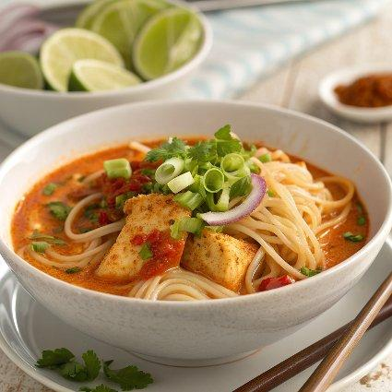

INGREDIENTS  - 7 oz pad thai noodles  - 1/4 cup peanut oil  - 1 lb mahi mahi (cut into cubes, or your favorite white meat fish)  - 2 cloves garlic (minced or grated)  - 6 green onions (chopped)  - 1/4 cup thai red curry paste  - 2 tbsp soy sauce  - 1 tbsp fish sauce  - 1 tbsp sambal oelek  - 2 tbsp lime juice  - 2 tbsp honey  - 2/3 cup canned coconut milk (plus more if needed)  - 8 oz fresh sugar snap peas  - 1/2 cup fresh cilantro (chopped)  - 1 mango (diced or sliced)  - 1/2 cup roasted peanuts (chopped)  - bean sprouts (red chilies + lime wedges, for serving) | PREP  COOK  1. Prepare the pad thai noodles according to package directions (mine said to soak my noodles in hot water for 10 minutes and then drain).  2. Meanwhile heat a large high sided skillet over medium heat. Add a drizzle of peanut oil and once hot, add half the fish. Sear the fish until just cooked through, about 3-5 minutes depending on the thickness of your fish. Remove from the pan and place on a plate. Add another drizzle of oil to the pan and repeat with the remaining fish, again adding the fish to the plate once it is finished cooking.  3. Return the pan to medium heat and add another drizzle of peanut oil. Add the garlic and green onions, cook for about 1 minute then add the thai red curry paste and continue to cook another 2 minutes or until fragrant. Add the soy sauce, fish sauce, sambal oelek, lime juice, honey and coconut milk. Bring the mixture to a low boil and cook for 5 minutes. After five minutes, add the sugar snap peas and the fish to the sauce. Cook until the fish is warmed through and the sauce has thickened, about another 5 minutes. If desired, add more coconut milk to thin the sauce if it seem too thick for your liking.  4. Remove from the heat and sir in the cilantro.  5. To serve, divide the noodles among bowls and top with curry. Serve with peanuts, fresh mango slices, bean sprouts and lime wedges if desired.  PLATING

