BEEF SHORT RIBS  COOK TIME: 4h 26m  SOURCE:  #comfort-food #hearty #slow-cooked | 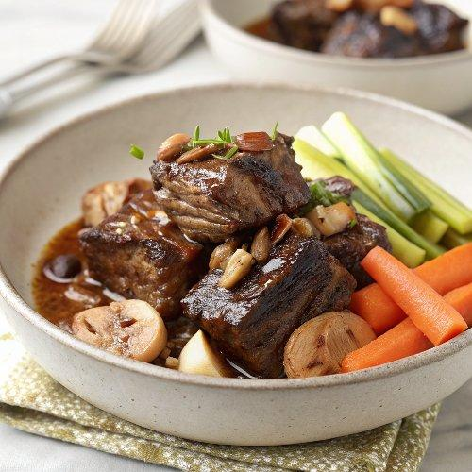

INGREDIENTS  - 6 beef short ribs, bone in (approx 1.6 kg)  - 2 heads of celery  - 6 carrots (600 g total)  - 50 g shelled unsalted walnut halves  - 1/2 x 345 g jar of onion marmalade  - 500ml (2.1 cups) smooth ale  - 6 baking potatoes (1.5 kg total)  - creamed horseradish, to serve | PREP  COOK  1. Preheat the oven to 160°C/325°F (160°C)/gas  3.  2. Put a large shallow casserole pan on a medium-high heat and brown the ribs all over, turning with tongs, for about 15 minutes.  3. Meanwhile, trim the celery and use a speed-peeler to remove the stringy outsides. Chop off the bottom 12cm (5-inch) of each and cut lengthways into quarters, then finely slice the remaining stalks, reserving any nice leaves. Peel the carrots, leaving them whole.  4. Once the ribs are browned, remove them to a bowl for a moment. Put all the celery and the carrots into the pan with the walnuts and onion marmalade and toss to coat. Season with sea salt and black pepper.  5. Pour in 600ml (2.5 cups) of water and the ale, then nestle the ribs back into the pan, making sure they’re submerged. Cover with a sheet of damp greaseproof paper and roast for 4 hours, or until the meat pulls easily away from the bone, basting halfway.  6. Scrub the potatoes, prick all over with a fork and bake alongside the ribs for the last 1 hour 30 minutes.  7. Skim any fat off the ribs, remove the bones and any wobbly bits and serve with dollops of horseradish, sprinkled with any reserved celery leaves, and the jacket spuds on the side.  PLATING

