PEPPERONI PASTA SALAD  COOK TIME: 15 min  SOURCE:  #quick #comfort-food #pasta | 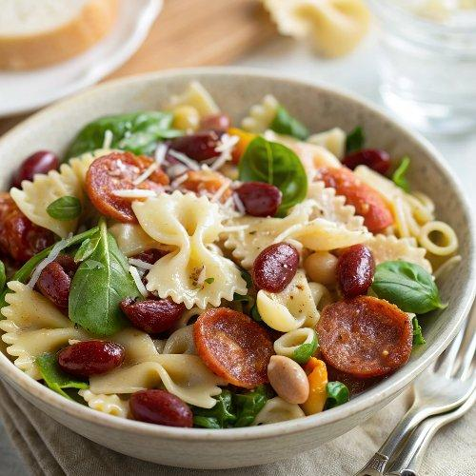

INGREDIENTS  - 8 oz. bowtie pasta ($0.66)  - 1/2 Tbsp salt (for pasta water) ($0.02)  - 4 oz. fresh baby spinach ($0.65)  - 15 oz. can kidney beans ($0.69)  - 3 oz. pepperoni ($1.25)  - 4 oz. mozzarella, cubed ($0.94)  - 1 pint grape tomatoes ($0.99)  - 6 oz. Italian or Caesar dressing ($2.00)  - 1 Tbsp Parmesan (optional) ($0.10)  - Freshly cracked pepper (optional) ($0.02) | PREP  COOK  1. Fill a medium sauce pot with water and add 1/2 Tbsp salt. Bring the pot of water to a boil over high heat, then add the pasta, and cook until tender. Drain the pasta in a colander and rinse briefly with cool water to bring the temperature down. Let the pasta drain well.  2. While the pasta is cooking, prepare the rest of the salad. Roughly chop the spinach leaves and place them in a large bowl. Rinse and drain the kidney beans, and slice the grape tomatoes in half. Add the beans, tomatoes, pepperoni, and cubed mozzarella to the bowl with the spinach.  3. When the pasta is cooked, cooled, and drained, add it to the bowl with the rest of the salad ingredients. Toss the ingredients until everything is combined. Add the salad dressing and then toss again until everything is coated. Serve the salad with a little Parmesan and some freshly cracked pepper sprinkled over top of each bowl  PLATING

