HEART SHAPED IMITATION CRAB OMELETTES  COOK TIME: 20 min  SOURCE:  #quick #comfort-food #egg-based | 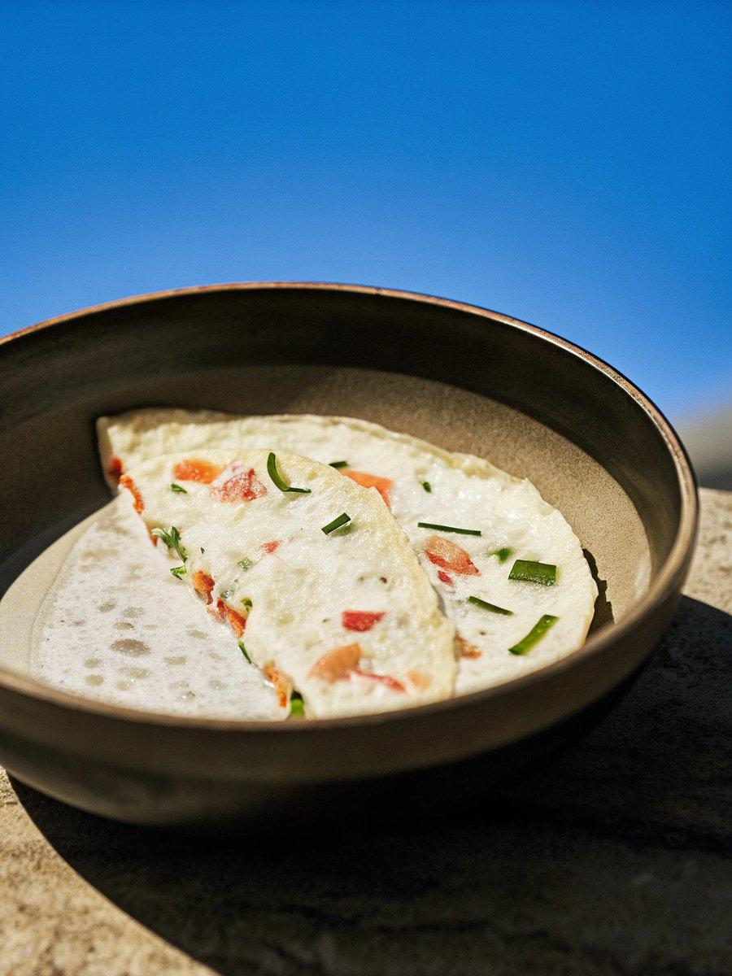

INGREDIENTS  - 2 eggs (large) beaten)  - 3 crab sticks (If frozen defrost them first before using them.)  - vegetables (- Your choice of colourful vegetables (e.g. bell peppers/capsicumcarrots and chives etc), finely chopped)  - 1 pinch salt  - Some cooking oil (I used rice bran oil) | PREP  COOK  1. Cut the crab sticks. Each one down the centre, lengthwise and then down the centre again for each. (So now you have four long sticks.) Bend both ends of crab sticks inwards to make the heart shape. Put through toothpicks or skewers to hold the shape in place.  2. Mix the egg, your choice of vegetables and salt in a mixing bowl.  3. Heat a skillet over low heat and add some cooking oil. Place the heart-shaped crab sticks on the skillet and fill the hole with the vegetable egg mixture (about 1 Tbsp per heart). Cook them over low heat covered. Once the egg is cooked (about 8 mins later), remove from the heat. Cool them down for 5 minutes. Remove the toothpicks or skewers. (I didn't turn over the heart during cooking to keep the heart colour pretty. Also, if you are picky about the visual presentation, you may want to cut the eggs that seep out outside of the heart boundary.)  4. Serve with some tomato sauce/ketchup.  PLATING

