SCALLION TOFU (葱烧豆腐)  COOK TIME: 10 min  SOURCE:  #tofu #quick #comfort-food | 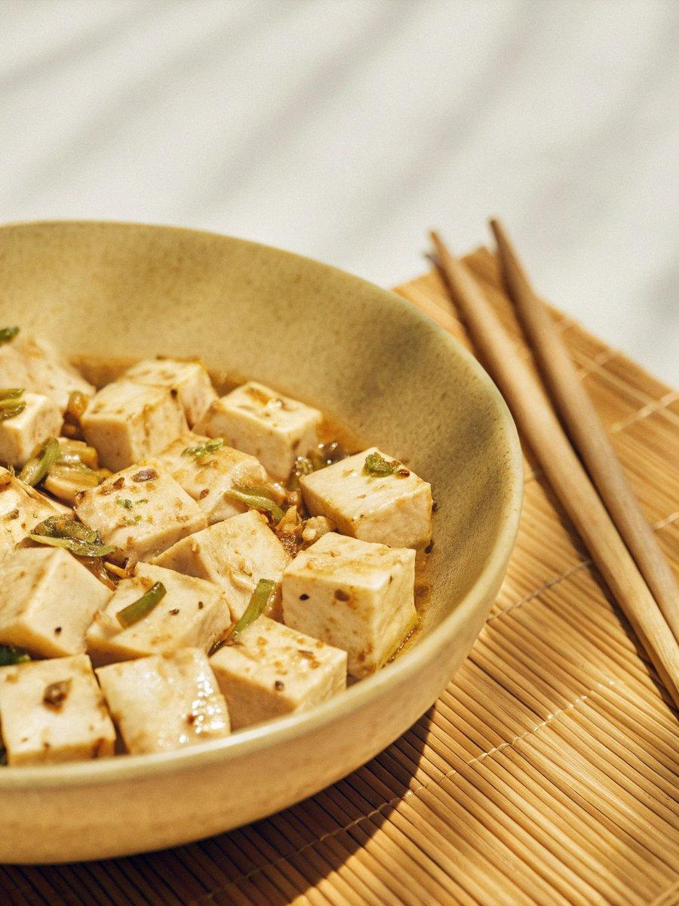

INGREDIENTS  - 1 lb tofu (preferably the firm type (see note 1)  - 8 stalks scallions  - 1/4 cup neutral cooking oil (see note 2 & 3)  - 2 tbsp light soy sauce  - 1/2 tbsp dark soy sauce  - 1/4 tsp sugar  - 1 cup (240ml) water  - 2 tsp cornstarch (mixed with 3 tsp of water) | PREP  COOK  1. Cut tofu into slices of around ¾ inch (2 cm) thickness. Pat dry their surface with kitchen paper.  2. Finely chop the white part of the scallions, then halve the green part.  3. Heat oil in a wok or skillet/frying pan. Gently slide in the tofu pieces. Arrange them in a single layer and leave to fry over medium heat until the bottom side turns golden. Flip over to fry the other side (see note 3 for air-frying method).  4. Transfer out the pan-fried tofu leaving any oil in the wok/skillet. Put in the chopped scallion white and fry until lightly brown.  5. Add light soy sauce, dark soy sauce, sugar, and water. Bring it to a full boil then put the tofu back in, along with the scallion greens. Leave to braise uncovered over high heat for about 2 minutes.  6. Turn the heat down to low. Pour in the cornstarch slurry (stir it well beforehand). Simmer until the sauce thickens to the desired consistency (just thick enough to coat the spatula).  PLATING

