PUMPKIN FRENCH TOAST  COOK TIME: 5 min  SOURCE:  #quick #comfort-food #breakfast | 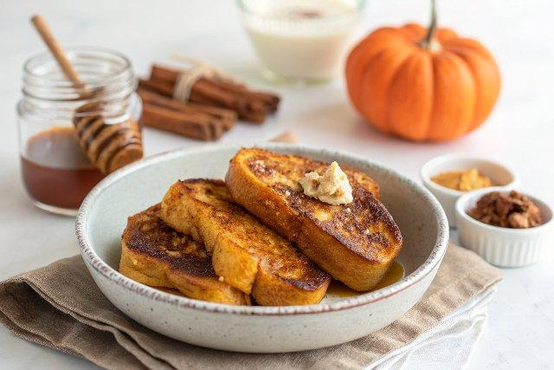

INGREDIENTS  - 1 cup (240ml) unsweetened soy milk  - 1/2 cup pumpkin pureé  - 1/4 cup cornstarch  - 2 tbsp packed brown sugar  - 1 tsp pure vanilla extract  - 1 tsp ground cinnamon  - 1/4 tsp ground nutmeg  - 1/4 tsp ground ginger  - 8-9 pieces thick bread, such as Texas toast or sourdough*  - vegan butter, for the pan | PREP  COOK  1. In a shallow bowl, wide enough to fit a piece of bread, whisk together the milk, pumpkin puree, cornstarch, brown sugar, vanilla, cinnamon, nutmeg and ginger together until well combined.  2. In a large non-stick pan, add a tablespoon or so of vegan butter (or coconut oil) over medium-high heat and let it melt. Whisk the batter once more right before dipping the bread.  3. Dip each side of the bread, then add to the pan and cook for 2-3 minutes on each side, until golden brown. Add more vegan butter to the pan as needed between slices.  4. Serve with vegan butter, maple syrup, powdered sugar and perhaps some vegan whipped cream and/or chopped pecans. Enjoy!  PLATING

