TUNA SALAD  COOK TIME: 15 min  SOURCE:  #quick #healthy #protein-rich | 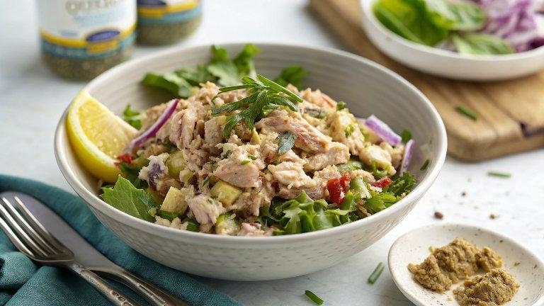

INGREDIENTS  - 4 (5-oz) cans tuna (well-drained)  - 5 tbsp mayonnaise  - 2 tbsp Dijon mustard  - 1 celery stalk (finely chopped)  - 1/4 cup diced red onion  - 2 tbsp fresh lemon juice  - 1/2 tsp salt  - 1/4 tsp ground black pepper | PREP  COOK  1. In a large bowl, add the tuna and break up any large pieces with a fork. Add the mayonnaise, mustard, celery, onion, lemon juice, salt, and pepper.  2. Stir together until combined. Taste and adjust salt and pepper, if desired.  3. Serve immediately or cover and refrigerate for up to 3 days.  PLATING

