BLUEBERRY, MELON, FETA, FRUIT SALAD STACKS  COOK TIME: 15 min  SOURCE:  #refreshing #healthy #summer | 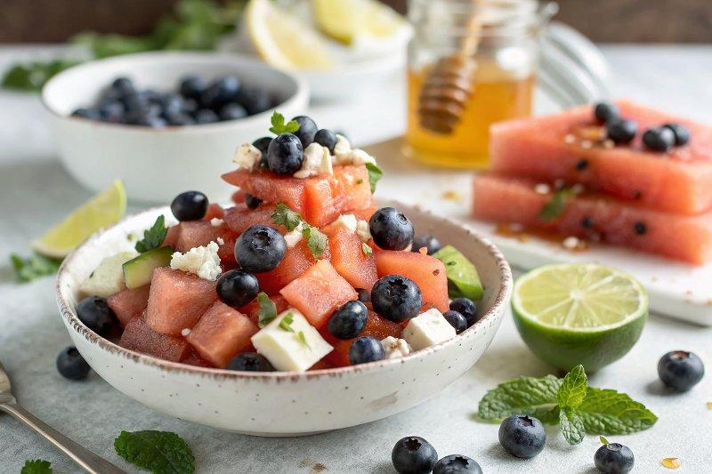

INGREDIENTS  - 1 small seedless watermelon  - 1 small cantaloupe  - 1 cup (240ml) blueberries  - juice and zest from 2 limes  - 1 tbsp honey plus, more to taste  - 1 fresno chile pepper, thinly sliced (optional)  - fresh mint and or basil  - flaky sea salt  - 1 (8 oz) block feta cheese, sliced into 1/4-inch (10cm) slices or crumbled | PREP  COOK  1.  1. Slice the watermelon and cantaloupe into 1/2-inch (5cm) slices. Remove the seeds from the cantaloupe. Cut the fruit slices into stars using cookie cutters or cut into 1-inch (3cm) cubes. Do the same with the feta. Arrange the fruit and on a large serving plate or layer into stacks. Save the scraps for snaking on.  2. Sprinkle the blueberries over top.  3. In a small bowl, stir together the zest of 1 lime and the juice of 2 limes, the honey, and the fresno pepper. Drizzle the dressing over the fruit. Add the fresh mint and a sprinkle of salt. Serve the fruit chilled, with extra honey if desired.  PLATING

