BLUEBERRY BANANA BREAD  COOK TIME: 40 min  SOURCE:  #healthy #quick #comfort-food | 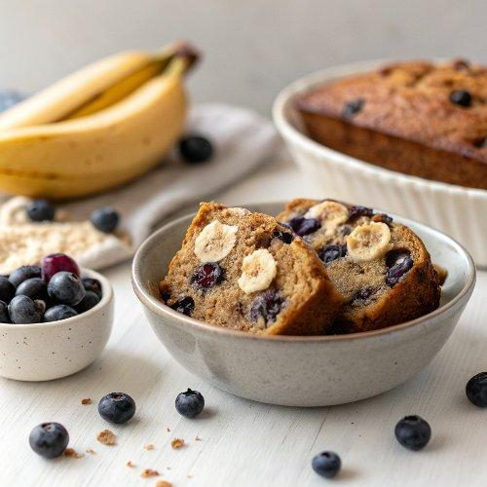

INGREDIENTS  - 2 cups (480ml) oat flour (gluten-free if needed (see notes)  - 1/2 cup ground almonds (almond flour) see notes)  - 1 tbsp ground chia seeds (or ground flax seeds)  - 1 tsp baking powder  - 1/4 tsp baking soda  - 2 ripe bananas  - 1/4 cup maple syrup (or any other liquid sweetener)  - 1/3 cup coconut milk (canned (see notes)  - 1 2/3 cup blueberries  - 2 tbsp lime juice (or lemon juice)  - 5 tbsp Erythritol (or powdered sugar)  - 1-2 tsp lime juice (see notes)  - 1 tbsp plant-based milk  - 2 tsp maqui berry powder (optional) | PREP  COOK  1. Add all dry ingredients to a bowl and stir until there are no clumps. Preheat oven to 360 degrees F (180 degrees C).  2. Process all wet ingredients (except the blueberries) in a food processor or blender and pour the mixture into the dry ingredients. Stir with a whisk, then fold in the blueberries.  3. Line a loaf pan with parchment paper. My pan measures 8 x 4 x 2.5-inch (13cm). Spoon the mixture into the pan.  4. Bake in the oven for about 40 minutes. The bread is ready when a toothpick inserted into the center of the loaf comes out almost clean (crumbly is fine but not wet). Let it cool completely.  5. For the maqui berry frosting: Process the Erythritol in your food processor or electric spice/coffee grinder until it's very fine like icing sugar. Add it to a small bowl and combine with the plant-based milk, the lime/lemon juice, and the Maqui berry powder. If the frosting is too thick add more milk or lime/lemon juice. If it's too thin, add more Erythritol. Spread the frosting over the bread and place it in the fridge until the frosting hardens. Enjoy!  PLATING

