TAIWANESE SALT AND PEPPER CHICKEN  COOK TIME: 20 min  SOURCE:  #fried #comfort-food #quick | 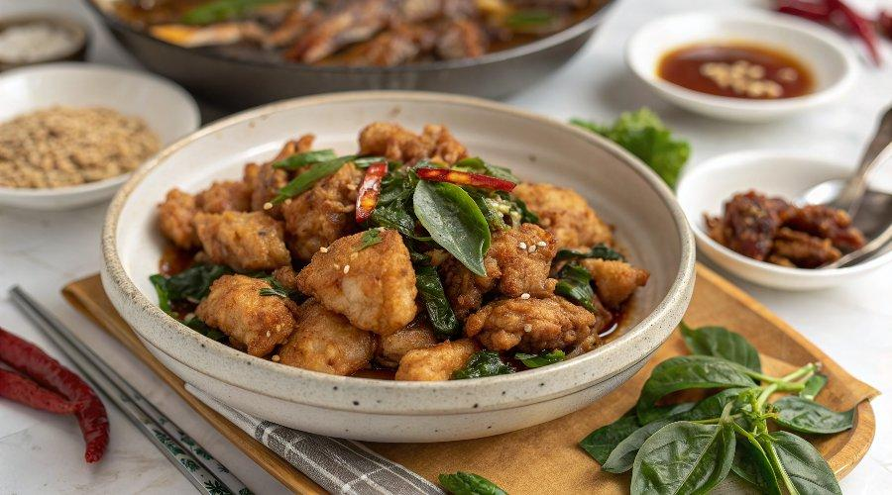

INGREDIENTS  - 8 oz (225 g) chicken breast (or thighs, cut into bite-size cubes )  - 1 cup (240ml) cornstarch  - 2 cups (480ml) oil (for deep-frying)  - 1 cup (240ml) fresh Thai basil leaves  - 1/4 tsp pepper salt  - 3 cloves garlic (minced)  - 1 tbsp ginger (minced)  - 1 tbsp soy sauce  - 1/4 tsp pepper salt ( or mix together 1/4 tsp of salt and 1/4 tsp of white pepper. )  - 1/2 tsp chicken bouillon (optional)  - 1 tbsp rice wine  - 1 tbsp water | PREP  COOK  1. Add garlic, ginger, soy sauce, pepper salt, chicken bouillon power, rice wine and water to chicken pieces and marinate for 30 minutes.  2. Coat the chicken evenly with cornstarch, shaking off the excess. Heat 2-3 inch (5-8cm)es (5cm-7cm) of oil in a pan or stock pot for deep-frying. Deep-fry the chicken until it turns light to golden brown. Then, add the Thai basil leaves to the oil. As soon as the leaves crisp up, remove the chicken and basil leaves from the oil using a strainer or slotted spoon, and place them in a mixing bowl.  3. Add the pepper salt and toss well with the chicken and basil leaves. Serve immediately.  PLATING

