CHIPOTLE SALSA  COOK TIME: 10 min  SOURCE:  #quick #spicy #fresh | 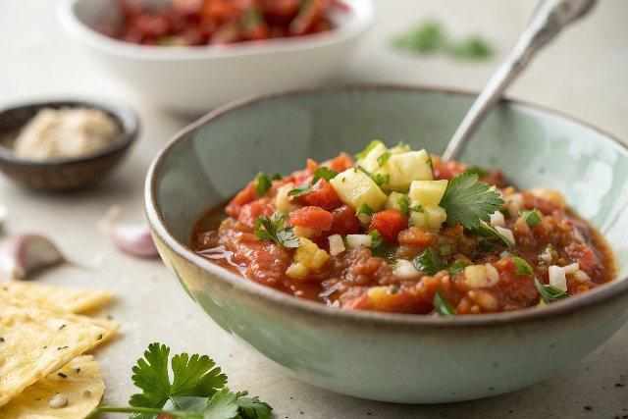

INGREDIENTS  - 1 can (15 oz) diced fire-roasted tomatoes*  - 1 clove garlic, roughly chopped  - 1/2 cup roughly chopped white onion (about 1/2 small onion)  - 1/4 cup lightly packed fresh cilantro leaves  - 1/2 medium jalapeño, seeds and ribs removed, and roughly chopped  - 1 to 3 chipotle peppers in adobo sauce  - 1 tbsp lime juice, more if needed  - 1/2 tsp fine salt | PREP  COOK  1. Drain off about half of the tomato juice from the can (about ⅓ cup) and discard it.  2. In a food processor, pulse the garlic to chop it more finely. Add the tomatoes and all of the remaining juice from the can. Add the onion, cilantro, jalapeño, 1 chipotle pepper, lime juice, and salt.  3. Process the mixture until it is mostly smooth and no big chunks of tomato or onion remain, scraping down the sides as necessary. Taste, and add another chipotle pepper or 2 if you prefer spicier salsa. Season to taste with additional lime juice and salt, if necessary.  4. Serve the salsa immediately or store it for later. This salsa keeps well in the refrigerator, covered, for about 10 days.  PLATING

