COLORFUL STRAWBERRY ARUGULA SALAD  COOK TIME: 25 min  SOURCE:  #fresh #healthy #quick | 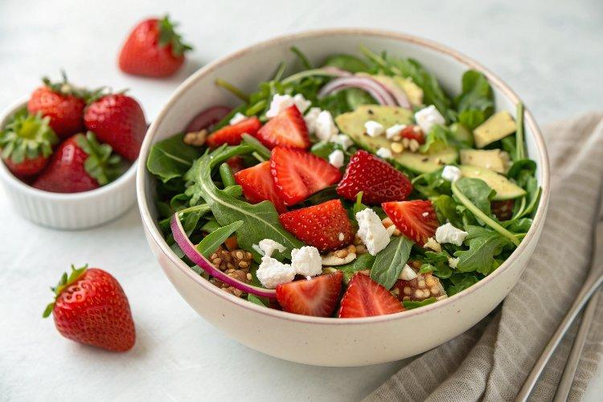

INGREDIENTS  - 5 oz arugula  - 1/2 cup chopped fresh basil  - 1 lb strawberries, thinly sliced  - 3/4 cup finely chopped red onion (about 1/2 small onion)  - 4 oz crumbled goat cheese or feta, or 1 ripe avocado, diced  - 1/2 cup roasted and salted sunflower seeds  - 1/2 cup halved and thinly sliced radish (about 3 medium)  - 1 medium jalapeño, very thinly sliced (omit if sensitive to spice)  - 1/4 cup extra-virgin olive oil  - 1 1/2 tbsp balsamic vinegar  - 1 tbsp Dijon mustard  - 1/2 tbsp maple syrup or honey  - 1 clove garlic, pressed or minced  - Pinch of fine sea salt, to taste  - Freshly ground black pepper, to taste | PREP  COOK  1. To assemble the salad: On a large serving platter or in a large serving bowl, layer the ingredients as listed.  2. To prepare the vinaigrette: In a liquid measuring cup or small bowl, combine all of the ingredients and whisk until fully blended. Taste, and add more salt or pepper if needed. The dressing should be nice and tangy, but you can add more maple syrup for balance if desired.  3. When you’re ready to serve the salad, drizzle vinaigrette on top, and toss to combine. Serve promptly. (If you’re planning to have leftovers, store the salad and dressing separately and toss before serving.) Stored separately, leftovers will keep well for 3 to 4 days.  PLATING

