AMBROSIA COOKIES  COOK TIME: 10 min  SOURCE:  #sweet #baking #cookies | 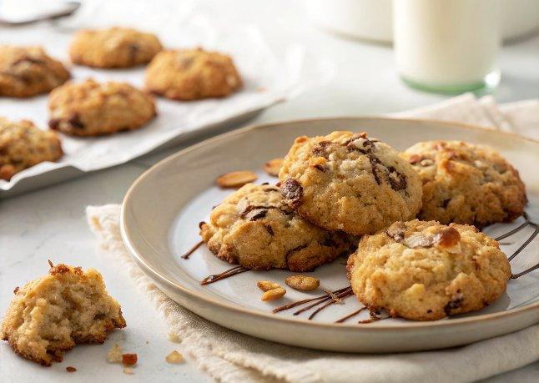

INGREDIENTS  - 1 cup (240ml) unsalted butter (softened)  - 1 cup (240ml) granulated sugar  - 1 cup (240ml) firmly packed light brown sugar  - 2 eggs  - 1 tsp pure vanilla extract  - 2 cups (480ml) flour  - 1 tsp baking powder  - 1/2 tsp baking soda  - 1/4 tsp salt  - 1 cup (240ml) sweetened flaked coconut  - 1 1/2 cups rolled oats  - 1 cup (240ml) chopped pecans  - 2 cups (480ml) golden raisins or chopped dates (I prefer dates)  - 1 tbsp grated lemon zest  - 1 tsp grated orange zest | PREP  COOK  1. Preheat oven to 375°F (190°C). Line baking sheets with parchment paper; set aside.  2. In a large bowl with an electric mixer or in the bowl of of a stand mixer fitted with the paddle attachment, cream the butter; gradually add the sugars, beating well. Add eggs and vanilla, beating well.  3. In a medium bowl, combine flour, baking powder, baking soda, salt, coconut, oats, pecans, raisins or dates, lemon zest and orange zest. Mix well. Stir into the butter mixture.  4. Use a medium cookie scoop to drop the dough onto the prepared baking sheets 2-inch (5cm) apart. Bake for 10-12 minutes. Remove to wire racks to cool.  PLATING

